11.Seizure / epilepsy
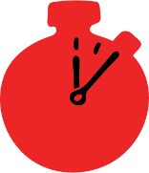
Group size

Whole group or small groups
Suggested timing

30 minutes
Method
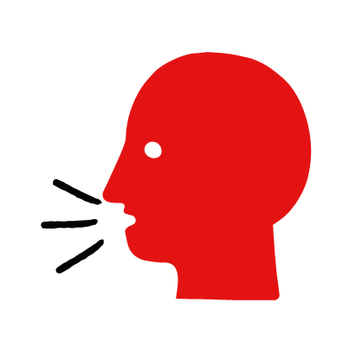

Discussion and film

Learning objectives
What you need
Seizure interactive activity (images and text) on the seizure first aid skill page

Learner skill guide ‘helping someone who is having a seizure’

- Learn first aid skills and about basic treatment for common injuries
- Feel confident to help someone who needs first aid
- Learn about helping others and kindness

Overview
Young people learn about seizures, what they are and what happens when someone is experiencing one. They then learn the steps to helping and the key action to take when someone is having a seizure.

Preparation
Ensure you can access the First aid champions website and can move through the interactive activity on the seizure first aid skill page. Display or print off the Learner skill guide ‘helping someone who is having a seizure’.

How to run the activity

- Ask young people:
- What happens when someone has a seizure?
They may have collapsed. Their body may stiffen and be making jerky movements. They may also have froth around their mouth.
- What is epilepsy?
It is a medical condition that can cause a person to have seizures although not everyone who has a seizure has epilepsy.
- How could you try to find out if someone has epilepsy?
There may be some form of identification or necklace on them such as a card, bracelet or necklace that gives information about their condition.
- Have you ever seen someone having a seizure? Do you know anyone who has epilepsy?
Make sure young people know they don’t need to share if they find a story upsetting, but if they want to share, explain that they are going to learn how to help someone who is having a seizure.
- What feelings might there be when someone is having a seizure?
It can be very worrying when someone has a seizure. It is okay to feel worried, the most important thing to do is to recognise what is happening and to act calmly to help them.
- What can you do to help someone who is having a seizure?
Explain that in the next part of the activity the group are going to learn how to help someone who is having a seizure.
- Now go to the seizure first aid skill page. Display the interactive activity on the web page, this will appear as a series of slides you can work through with the group. Alternatively, you could set the group up with individual or shared screens to work through the activity.
- Display or direct the group to the confidence slider on the seizure first aid skill page, either setting this as an individual task or discussing as a group. How confident do learners feel to help someone who is having a seizure?
- On the seizure first aid skill page, watch Leo’s story. After showing the story, ask young people:
- What was happening in Leo’s story?
- How did they recognise Ethan was having a seizure?
- How might they have felt? Think about the person having the seizure, the person who helped and anyone else nearby.
- What did they do to help? What were they good at? What qualities did they show? What can you learn from this? How could you use it?
- Direct the group to the confidence slider on the seizure first aid skill page and complete it again.
- Display or hand out the Learner skill guide ‘helping someone who is having a seizure’. In small groups, or as a whole group look at the learner skill guide and discuss again some of the signs of a seizure and what they would do to help.
- Individually, or in small groups, choose one of the creative tasks below to complete the activity:
- Write or create a poster of how to recognise a seizure and how to help someone who is having one.
- Create your own seizure story. They could map this out in pictures that they take as a group with text alongside, or just write text. They can create their story as a PowerPoint or as a short animation. Ensure that young people show the key action to take to help someone who is having a seizure and get this across as part of their story. They can then share with the rest of the group – time allowing.

Summing up
- Remind the group that the most important thing to do is to help.
- Now practise how to help someone who is having a seizure.

