Restart a Heart Day 2020

Use this Restart a Heart day resource on 16 October 2020 to support your learners to learn how to help someone who is unresponsive and not breathing, including how to recognise, find and use an Automated External Defibrillator (AED). Activities are taken from our First Aid Champions resource and our Direct Delivery workshops.
Recommended ages: 11 - 16 Suggested timing: 1 hour
Learning objectives
At the end of the session learners will be able to:
- Consider and discuss their thoughts about helping others
- Describe the barriers to helping and what might contribute to someone not feeling able help.
- Feel confident and have the skills to help someone who is unresponsive and not breathing.
- Get 999 help in a medical emergency.

Starter activity: Inspiring you to help
Start by sharing this quote with the whole group.
"Be the change you wish to see in the world".
Ask learners to consider the quote – what do they think it means? Does it resonate with them? How might it apply to their own lives and their learning around first aid and helping others?
Ask learners to think of any people or quotes that inspire them. If they have some ideas, hold a group discussion about why they find these people and/or quotes inspirational – they might consider the motivation of the person.
Core activity: Would you help them? Walking debate
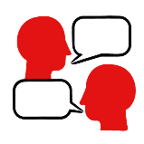
Show the learners the three images on the PowerPoint/or describe scenarios where someone is collapsed. For each photo, ask the learners the question: Would you help this person? Learners should place themselves along an imaginary line across the room to show how likely they would be to help in this situation.

Suggested questions for discussion:
- Why would you help this person?
- What is stopping you helping this person?

Possible answers:
Not knowing what to do; not understanding the situation; thinking someone else will help; danger; embarrassment; age; gender; lack of time; fear of getting involved; fear of getting it wrong; fear of being sued, etc.
Suggested questions for discussion:
- Are there solutions to these barriers?
- Is it important to help?
- What are the consequences of not helping?
It is especially important to produce solutions for all barriers. Otherwise, this activity can decrease propensity to act. However, if there is a clear danger, the young person should keep themselves safe as a priority. They can always alert an adult or call 999 once they are safe themselves. Even calling 999 is doing something. Discuss the importance of helping others, even a small act of helping can make an enormous difference.

Core activity: Learn the skill: helping someone who is unresponsive and not breathing
In this activity, you can use the ‘Restart a Heart Day’ PowerPoint Presentation to show the first aid skills or you can access the First aid champions website and can move through the interactive pages on the unresponsive and not breathing first aid skill page.
Ask the learners:
- What does unresponsive mean?
This is when someone is not moving and does not respond when you call their name or shake their shoulders.
- How can you check if someone is breathing?
COVID- 19 guidance: When checking if a person is breathing do not listen or feel for breathing by placing your ear and cheek close to the person's mouth. Look for a rise and fall of their chest or stomach and normal breathing. If you are unsure, assume they are not breathing. Continue with first aid key actions.
- Have you ever seen someone who is unresponsive and not breathing? On TV or in a film?

Make sure young people know they don’t need to share if they find a story upsetting, but if they want to share, explain that they are going to learn how to help someone who is unresponsive and not breathing.
- What feelings might there be when someone is unresponsive and not breathing?
It can be very worrying when someone is unresponsive and not breathing. It is okay to feel worried, the most important thing to do is to act quickly to help them and try to stay calm.
- What can you do to help someone who is unresponsive and not breathing?
Explain that in the next part of the activity the group are going to learn how to help someone who is unresponsive and not breathing.
Now go to the unresponsive and not breathing first aid skill page. Display the interactive activity on the web page, this will appear as a series of slides you can work through with the group. These are also on the ‘Restart a Heart Day 2020’ PowerPoint.

On the unresponsive and not breathing first aid skill page, watch Kelly’s story. After showing the story, ask young people:
- What was happening in Kelly’s story?
- What did Kelly do when she found her nan?
- How might Kelly have felt? Think about the Tom next door, how might he have felt?
- What is the action that Tom took to help? What were they good at? What qualities did they show? What can you learn from this? How could you use it?

Show the short-animated film which appears in the activity on the last slide of the unresponsive and not breathing first aid skill page. This shows what happens in the body when someone is unresponsive and not breathing.

Display or hand out the Learner skill guide ‘helping someone who is unresponsive and not breathing. In small groups, or as a whole group look at the learner skill guide and discuss again how to identify if someone is unresponsive and not breathing and how to help.

Individually, or in small groups choose one of the creative tasks below to complete the activity:
- Write or create a poster of how to identify if someone is unresponsive and not breathing and the key action to take to help.
- Create your own unresponsive and not breathing story. They could map this out in pictures that they take as a group with text alongside, like in Kelly’s story, or just write text. They can create their story as a PowerPoint or as a short animation. Ensure that young people show the key action to take to help someone who is unresponsive and not breathing and get this across as part of their story. They can then share with the rest of the group – time allowing.
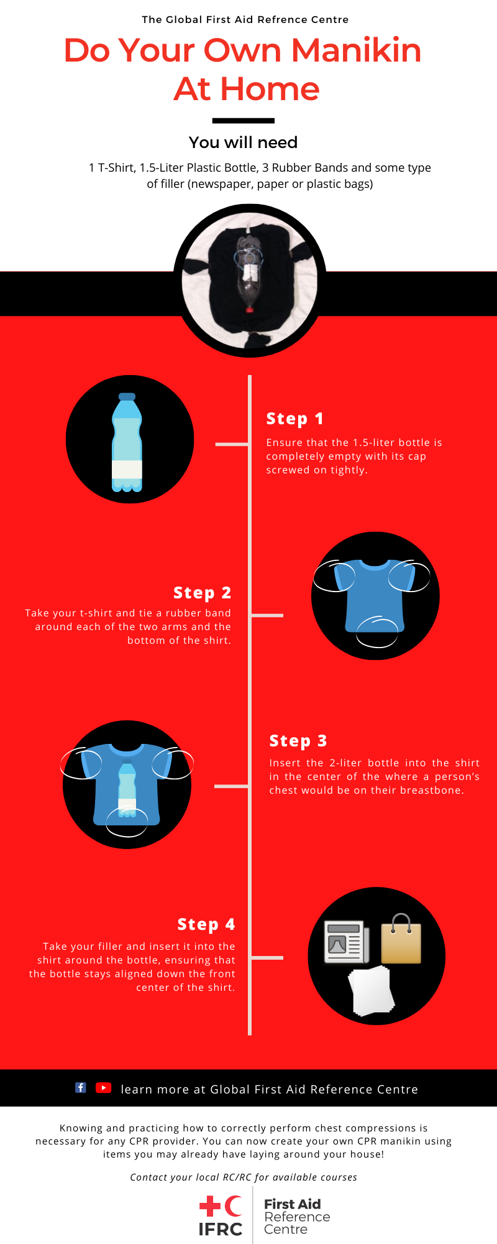
The Global First Aid Reference Center devised a way of making a manikin that you could p practice chest compressions with.

Core activity: Using an AED
Young people learn about someone who is unresponsive and not breathing and what this means and what an AED is. They then learn the steps to helping and the key action to take when someone is unresponsive and not breathing and there is an AED available.
- What is an AED?
AED stands for automated external defibrillator. It is a machine that can shock someone’s heart if it is not working properly. The AED will only shock someone if they need it – it will never shock a healthy heart. It gives instructions on how to use it so anyone can use it.
- Have you ever seen an AED? Where?
AEDs are available in lots of public places, such as train stations, shopping centres and schools.
- What can you do to help someone who is unresponsive and not breathing when an AED is available?
Explain that in the next part of the activity the group are going to learn how to help someone who is unresponsive and not breathing when an AED is available.
Now go to the unresponsive and not breathing (AED) first aid skill page. Display the interactive activity on the web page, this will appear as a series of slides you can work through with the group.
Display or direct the group to the confidence slider on the unresponsive and not breathing (AED) first aid skill page, either setting this as an individual task or discussing group. How confident do learners feel to help someone who is unresponsive and not breathing when an AED is available?
On the unresponsive and not breathing (AED) first aid skill page, move through CJ’s story, displayed as a series of images and text. After showing the story, ask young people:
- What was happening in CJ’s story?
- How might CJ have felt? How might Joy and other people nearby have felt?
- What is the action that CJ took to help? What else were they good at? What qualities did they show? What can you learn from this? How could you use it?
Display or hand out the Learner skill guide ‘helping someone who is unresponsive and not breathing when an AED is available’. In small groups, or as a whole group, look at the learner skill guide and discuss again how they can identify if someone is unresponsive and not breathing and what they would do to help if an AED is available.
Individually, or in small groups choose one of the creative tasks below to complete the activity:
- Write or create a poster of how to identify if someone is unresponsive and not breathing and the key action to take if an AED is available.

Extension activity: Calling 999
Ask learners to read the calling 999 learner skill guide and feedback on:
- What to expect when you call 999
- What to do to help the 999-call handler
In small groups or pairs ask learners to identify the key pieces of information the call handler will ask for. Bring the groups together to discuss their ideas.
Remind leaners that calling 999 is simple – the call handler will ask you the questions and prompt you for the answers when needed.

Concluding activity: One, two, three – first aid learning
Working individually, in pairs or small groups, ask the learners to discuss what they have learnt from the first aid session(s) – then ask them to think of:
  - one thing that surprised them about what they learnt;
  - two questions they want to ask about what they have learnt; and
  - three key takeaways: one they will remember; one they will act on and one they will pass on to others.
They can feedback as a whole group.
Extending the learning

