6.Head injury
Group size

Whole group or small groups
Suggested timing

30 minutes
Method
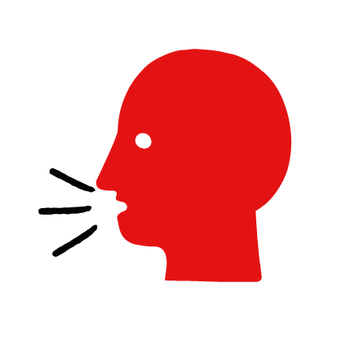

Discussion and film

Learning objectives
What you need
Head injury interactive activity (images and text) on the head injury first aid skill page

Learner skill guide ‘helping someone who is having a head injury’

- Learn first aid skills and about basic treatment for common injuries
- Feel confident to help someone who needs first aid
- Learn about helping others and kindness

Overview
Young people learn about head injuries, what they are and what happens when someone has one. They then learn the steps to helping and the key action to take when someone has a head injury.

Preparation
Ensure you can access the First aid champions website and can move through the interactive activity on the head injury first aid skill page. Display or print off the Learner skill guide ‘helping someone who has a head injury.

How to run the activity

- Ask young people:
- What could cause someone to have a head injury?
Head injuries are caused when someone has an accident where they hit their head.
- What happens when someone has a head injury?
They may be in pain, have a headache and have a lump on their head. If someone has a serious head injury they may also feel sick, confused or drowsy.
- Have you ever had a head injury or seen someone have a head injury? What happened?
Make sure young people know they don’t need to share if they find a story upsetting, but if they want to share, explain that you are going to learn how to help someone who is has a head injury.
- What feelings might there be when someone has a head injury?
It can be very worrying when someone has a head injury. It is okay to feel worried, the most important thing to do is to recognise what is happening and to calmly help them.
- What can you do to help someone who has a head injury?
Explain that in the next part of the activity the group are going to learn how to help someone who has a head injury.
- Now go to the head injury first aid skill page. Display the interactive activity on the web page, this will appear as a series of slides you can work through with the group. Alternatively, you could set the group up with individual or shared screens to work through the activity.
- Display or direct the group to the confidence slider on the head injury first aid skill page, either setting this as an individual task or discussing as a group. How confident do learners feel to help someone who has a head injury?
- On the head injury first aid skill page, move through Nick’s story, displayed as a series of images and text. You could ask learners to read out the slides. After showing the story, ask young people:
- What was happening in Nick’s story?
- What caused Simon’s head injury?
- How might they have felt? Think about the person with the head injury, the person who helped and anyone else nearby.
- What is the action that Nick took to help? What else were they good at? What qualities did they show? What can you learn from this? How could you use it?
- Show the short-animated film which appears in the activity on the head injury first aid skill page, this shows what happens in the body when someone has a head injury. Direct the group to the confidence slider on the head injury first aid skill page and complete it again.
- Display or hand out the Learner skill guide ‘helping someone who has a head injury’. In small groups, or as a whole group look at the learner skill guide and discuss again some of the signs of a head injury and what they would do to help.
- Individually, or in small groups choose one of the creative tasks below to complete the activity:
- Write or create a poster of how to recognise a head injury and the key action to take when someone has a head injury.
- Create your own head injury story. They could map this out in pictures that they take as a group with text alongside, like in Nick’s story, or just write text. They can create their story as a PowerPoint or as a short animation, ensure that young people show the key action to take to help someone who has a head injury and get this across as part of their story. They can then share with the rest of the group – time allowing.

Summing up
- Remind the group that the most important thing to do is to help.
- Now practise how to help someone who has a head injury.

