4.Burns
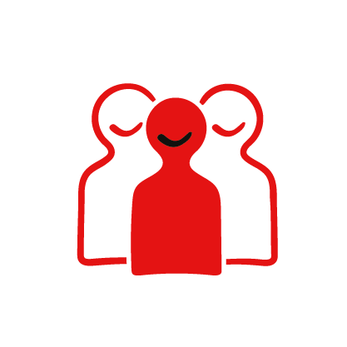
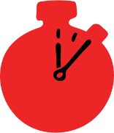
Group size

Whole group or small groups
Suggested timing

30 minutes
Method
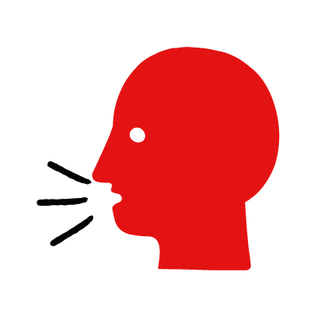

Discussion and film

Learning objectives
What you need
Burn interactive activity (images and text) on the burns first aid skill page

Learner skill guide ‘helping someone who has a burn’

- Learn first aid skills and about basic treatment for common injuries
- Feel confident to help someone who needs first aid
- Learn about helping others and kindness

Overview
Young people learn about burns, what they are and what happens when someone is experiencing one. They then learn the steps to helping and the key action to take when someone has a burn.

Preparation
Ensure you can access the First aid champions website and can move through the interactive pages on the burns first aid skill page. Display or print off the Learner skill guide ‘helping someone who has a burn.

How to run the activity

- Start with these questions to establish current learning and to open the topic. Ask young people:
- What happens when someone has a burn?
The person will have redness and severe pain after coming into contact with something hot.
- What could cause someone to have a burn?
Burns are caused by something hot coming into contact with the skin. It could be a hot surface – such as an oven or hair straighteners, or a hot liquid – such as hot water from the kettle or a hot drink.
- Have you ever had a burn or know someone who has had a burn? What happened?
Make sure young people know they don’t need to share if they find a story upsetting, but if they want to share, explain that they are going to learn how to help someone who has a burn.
- What feelings might there be when someone has a burn?
It can be very worrying when someone has a burn. It is okay to feel worried, the most important thing to do is to act quickly and calmly to help them.
- What can they do to help someone who is has a burn?
Explain that in the next part of the activity the group are going to learn how to help someone who has a burn.
- Now go to the burns first aid skill page. Display the interactive activity on the web page, this will appear as a series of slides you can work through with the group. Alternatively, you could set the group up with individual or shared screens to work through the activity.
- Display or direct the group to the confidence slider on the burns first aid skill page, either setting this as an individual task or discussing as a group. How confident do learners feel to help someone who has a burn?
- On the burn first aid skill page, watch Sam’s film. After showing the story, ask young people:
- What was happening in Sam’s story?
- What caused Sam’s burns?
- What did Sam’s friends do to help?
- How might they have felt? Think about the person with the burn, the person who helped and anyone else nearby.
- What is the key action that Sam’s friends took to help? What else were they good at? What qualities did they show? What can you learn from this? How could you use it?
- Show the short-animated film which appears in the activity on the last slide of the burn first aid skill page, this shows what happens in the body when someone has a burn. Direct the group to the confidence slider on the burn first aid skill page and complete it again.
- Display or hand out the Learner skill guide ‘helping someone who is has a burn’. In small groups, or as a whole group look at the learner skill guide and discuss again some of the causes of burns and what they would do to help.
- Individually, or in small groups choose one of the creative tasks below to complete the activity:
- Write or create a poster of causes of burns and the key action to take when someone has a burn.
- Create your own burn story. They could map this out in pictures that they take as a group with text alongside, or just write text. They could create their story as a PowerPoint or as a short animation. Ensure that young people show the key action to take to help someone who has a burn and get this across as part of their story. They can then share with the rest of the group – time allowing.

Summing up
- Remind the group that the most important thing to do is to help.
- Now practise how to help someone who is has a burn.

