Why is first aid important?
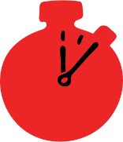
Activity type

Whole group
Suggested timing

15-20 minutes
Method
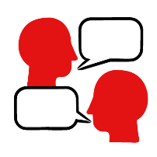

Walking debate / discussion

Learning objectives
What you need

PowerPoint

Printed agree, disagree and unsure wall signs

- Understand what first aid is
- Feel able to help someone in need of first aid

Overview
Children take part in a walking debate to discuss why first aid is important.

Preparation
Choose some or all the statements below, either read them out or display them on the PowerPoint. If you are running this activity as a walking debate, ensure the room is clear enough for learners to move from one side to the other. Label one side of the room ‘agree’ and the other side ‘disagree’, with the middles as ‘unsure’ using the print out wall signs if needed.

How to run the activity
- Discuss what is meant by “first aid”, you could define this as first person on the scene to help someone in need of aid/assistance.
- Explain that you will share some statements one at a time. After each statement is read out or displayed, children choose whether they agree or disagree and move towards the side of the room with that label, if they are not sure they can stay toward the middle. If learners are seated you could: ask them to raise their hands if they agree, stand up if they disagree or keep their hands down if they are undecided.
- Reading out or displaying the statements (below), ask learners to show if they agree or disagree or are undecided. After each statement invite some learners with different opinions to give reasons why they agree, disagree or are undecided, there is no right or wrong answer – this is to get them thinking and to see that there are a range of perspectives.
Statements:
  - I would know how to help someone in a first aid emergency
  - It’s important to know first aid
  - People should always get the help they need in a first aid emergency
  - You should always help a stranger who needs first aid (for this statement ensure there is discussion about keeping yourself safe)
  - Not everyone deserves help in a first aid emergency
  - We all have a responsibility to help others
  - You should always make sure you are safe before helping others

Summing up
Wrap up the activity by asking learners if anything surprised them or made them think differently.

