1. Asthma attack
Group size

Whole group or small groups
Suggested timing

30 minutes
Method
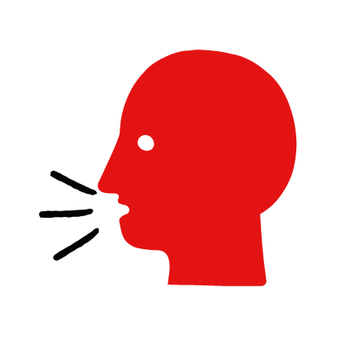

Discussion and film

Learning objectives
What you need
Asthma attack interactive activity (images and text) on the asthma attack first aid skill page

Learner skill guide ‘helping someone who is having an asthma attack’

- Learn how to recognize when someone is having an asthma attack.
- Learn the key action to help when someone is having an asthma attack.

Overview
Young people learn about asthma attacks, what they are and what happens when someone is experiencing one. They then learn the steps to helping and the key action to take when someone has an asthma attack so that they are more able, willing and confident to help.

Preparation
Ensure you can access the First aid champions website and can move through the interactive pages on the asthma attack first aid skill page. Display or print off the Learner skill guide ‘helping someone who is having an asthma attack’.

Familiarise learners with the ground rules for the session or establish ground rules. For guidance on how to do that, see the Creating a safe, inclusive and supportive learning environment guidance.

How to run the activity

- Ask young people:
- What is an asthma attack? When someone with asthma finds it difficult to breathe because the tubes that they breathe through (their airways) become swollen and narrow.
- What happens when someone has an asthma attack? They will find breathing difficult. They may make a wheezing sound and cough.
- What could cause someone to have an asthma attack? Asthma is a medical condition, so the person will probably already know they have asthma. An attack could be caused by someone having a cold or chest infection, exercise, changes in the weather, or dust.
- What feelings might there be when someone is having an asthma attack? It can be very worrying when someone has an asthma attack. It is okay to feel worried, the most important thing to do is to recognise what is happening and to calmly help them.
- What can you do to help someone who is having an asthma attack? Explain that in the next part of the activity the group are going to learn how to help someone who is having an asthma attack.
- Now go to the asthma attack first aid skill page. Display the interactive activity on the web page, this will appear as a series of slides you can work through with the group. Alternatively, you could set the group up with individual or shared screens to work through the activity.
- Display or direct the group to the confidence slider on the asthma attack first aid skill page, either setting this as an individual task or discussing as a group. How confident do learners feel to help someone who is having an asthma attack?
- On the asthma attack first aid skill page, move through Dan’s story, displayed as a series of images and text. You could ask learners to read out the slides. After showing the story, ask young people:
- What was happening in Dan’s story? He was playing basketball with his friends and Josh had an asthma attack.
- What caused Josh’s asthma attack? Doing too much exercise without resting.
- What is the key action that the friends took to help? Helped him rest and take his inhaler.
- What were they good at? What qualities did they show? They might say things like, calm under pressure, kind, supportive.
- How might they all have felt? Think about the person having the asthma attack, the person who helped and anyone else nearby. They might say things like, worried, scared but also ready to act, supported, safe.
- Show the short-animated film which appears in the online activity of the asthma attack first aid skill page, this shows what happens in the body when someone has an asthma attack.

Questions learners might ask
Learners might have questions about this skill. Remember to provide an anonymous question box for questions they wish to ask privately. The key skills are the most important things they should remember, but you can find some extra information which might help you answer their questions here:
- How do you use an inhaler?
If a person has asthma they should know how to use their inhaler, they may need your help getting it for them. They may also have a spacer. Different people may have different types of spacer or inhaler, make sure they only use theirs.
They should take it as normal. If that doesn’t help they can take one or two puffs every 30 or 60 seconds until they’ve had 10 puffs.
- When should I call 999 for an asthma attack?
If there is no adult around to help you when someone is having an asthma attack call 999. Even if there is an adult, you should call 999 if they get worse after they’ve taken their inhaler, if they don’t have an inhaler or this is the first asthma attack they’ve had.
- What is asthma?
Asthma is a medical condition that affects the ‘airways’ – the tubes that carry air in and out of your lungs. When someone has an asthma attack, these tubes become narrower, making it hard to breathe in and out.

- Display or hand out the Learner skill guide ‘helping someone who is having an asthma attack’. In small groups or as a whole group, discuss again some of the signs of an asthma attack and key actions to help.
- Direct the group to the confidence slider on the asthma attack first aid skill page and complete it again.
- Check what learners have learned by doing the asthma attack quiz.

Stretch and challenge activities:
- Ask learners to explain or write down the key steps to help someone who is having an asthma attack. They could create a diagram to show what someone having an asthma attack might look like and the key actions someone helping should do.
- Compare their work to the photos of the webpage, did they miss anything? Could they add details of how someone can help support the person who is having an asthma attack emotionally too?

Summing up
- Remind the group that the most important thing to do is to help by helping them take their inhaler.
- Now practise how to help someone who is having an asthma attack with the practise activity.

