5.Choking
Group size

Whole group or small groups
Suggested timing

30 minutes
Method
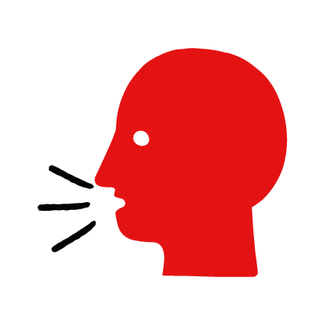

Discussion and film

Learning objectives
What you need
Choking interactive activity (images and text) on the choking first aid skill page

Learner skill guide ‘helping someone who is choking’

- Learn how to recognize when someone is choking.
- Learn the key action to help when someone is choking.

Overview
Young people learn about choking, what causes it and what happens when someone is choking. They then learn the steps to helping and the key action to take when someone is choking so that they are more able, willing and confident to help.

Preparation
Ensure you can access the First aid champions website and can move through the interactive activity on the choking first aid skill page. Display or print off the Learner skill guide ‘helping someone who is choking’.

Familiarise learners with the ground rules for the session or establish ground rules. For guidance on how to do that, see the Creating a safe, inclusive and supportive learning environment guidance.

How to run the activity

- Ask young people:
- What happens when someone is choking? They will be unable to speak, cough or breathe. They may be clutching at their chest or neck.
- What causes someone to choke? Choking is caused by a blockage in someone’s airway (the tube that they breathe through). It usually happens when eating, by food ‘going down the wrong way’.
- What feelings might there be when someone is choking? It can be very worrying when someone is choking. It is okay to feel worried, the most important thing to do is to recognise what is happening and to act quickly and calmly to help them.
- What can you do to help someone who is choking? Explain that in the next part of the activity the group are going to learn how to help someone who is choking.
- Now go to the choking first aid skill page. Display the interactive activity on the web page, this will appear as a series of slides you can work through with the group. Alternatively, you could set the group up with individual or shared screens to work through the activity.
- Display or direct the group to the confidence slider on the choking first aid skill page, either setting this as an individual task or discussing as a group. How confident do learners feel to help someone who is choking.
- On the choking first aid skill page, watch Amina’s film. After showing her story, ask young people:
- What was happening in Amina’s story? She is walking and eating a breakfast bar and she starts to choke.
- What caused Amina to start choking? She was eating as she laughed with her friend and a piece got lodged in her throat.
- How might they have felt? Think about the person choking, the person who helped and anyone else nearby. They might say things like, worried, scared or things like ready to help, supported, relieved.
- What is the action that Amina’s friend took to help her? She gave her five back blows and five abdominal thrusts.
- What else was she good at? What qualities did she show? They might say things like, calm under pressure, quick to act or kind.
- Show the short-animated film which appears in the macro on the last slide of the choking first aid skill page, this shows what happens in the body when someone is choking.

Questions learners might ask

Learners might have questions about this skill. Remember to provide an anonymous question box for questions they wish to ask privately. The key skills are the most important things they should remember, but you can find some extra information which might help you answer their questions here:
- Are abdominal thrusts the same as the Heimlich manoeuvre?
Yes, they are the same.
- What if the person is too big and I can’t wrap my arms around them?
If they are much bigger than you, call for an adult to do the actions. If there is no adult around, just focus on giving the five back blows.
- What should I do if the person becomes unresponsive?
If the person becomes unresponsive then you should support them gently to the ground and treat them as an unresponsive person who is not breathing.

- Display or hand out the Learner skill guide ‘helping someone who is choking’. In small groups, or as a whole group look at the learner skill guide and discuss again some of the signs of choking and what someone would do to help.
- Direct the group to the confidence slider on the choking first aid skill page and complete it again.
- Check what learners have learned by doing the choking quiz.

Stretch and challenge activities:
- Ask learners to explain or write down the key steps to help someone who is choking. They could create a diagram to show what someone who is choking might look like and the key actions someone helping should do.
- Compare their work to the photos of the webpage, did they miss anything? Could they add details of how someone can help support the person who is choking emotionally too?

Summing up
- Remind the group that the most important thing to do is to give five back blows and if needed, five abdominal thrusts.
- Now practise how to help someone who is choking with the practice activity.

