10. Poisoning / harmful substances
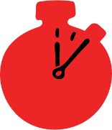
Group size

Whole group or small groups
Suggested timing

30 minutes
Method
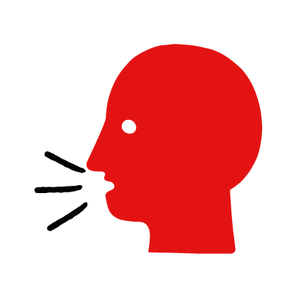

Discussion and film

Learning objectives
What you need
Harmful substances interactive activity (images and text) on the Poisoning / harmful substances first aid skill page

Learner skill guide ‘helping someone who has swallowed something harmful’

- Learn how to recognise when someone has swallowed something harmful.
- Learn the key action to help when someone has swallowed something harmful.

Overview
Young people learn about poisoning and what happens when someone swallows something harmful. They then learn the steps to helping and the key action to take when someone has swallowed something harmful, so that they are more able, willing and confident to help.

Preparation
Ensure you can access the First aid champions website and can move through the interactive pages on the harmful substances first aid skill page. Display or print off the Learner skill guide ‘helping someone who has swallowed something harmful’.

Familiarise learners with the ground rules for the session or establish ground rules. For guidance on how to do that, see the Creating a safe, inclusive and supportive learning environment guidance.

How to run the activity

- Ask young people:
- What is a harmful substance?
Substances such as prescription or non-prescription drugs, household cleaning fluids and DIY products, and some plants can be harmful if you swallow them.
- What would make you think someone may have swallowed something harmful?
Someone may vomit and have stomach pains. There may be evidence of the harmful substance around their mouth or you may smell it. There may be empty containers nearby.
  - What feelings might there be when someone has swallowed something harmful?
It can be very worrying when someone has swallowed harmful. It is okay to feel worried, the most important thing to do is to recognise what has happened and to act quickly and calmly to help them.
- What can you do to help someone who has swallowed something harmful?
Explain that in the next part of the activity the group are going to learn how to help someone who has swallowed something harmful.
- Now go to the harmful substances first aid skill page. Display the interactive activity on the web page, this will appear as a series of slides you can work through with the group. Alternatively, you could set the group up with individual or shared screens to work through the activity.
- Display or direct the group to the confidence slider on the harmful substances first aid skill page, either setting this as an individual task or discussing group. How confident do learners feel to help someone who has swallowed something harmful.
- On the harmful substances first aid skill page, move through Jade’s story, displayed as a series of images and text. You could ask learners to read out the slides. After showing the story, ask young people:
- What was happening in Jade’s story? Her cousin and friend Carly sent her a strange voicemail and she worried she had taken something harmful and rushed to her.
- Why was she worried about her friend? She sounded slurred on the phone and mentioned medication.
- How might they have felt? Think about the person who had swallowed something harmful, the person who helped and anyone else nearby. They might say things like worried, panicked or scared but also things like determined and ready to help.
- What is the action that Jade took to help? She called 999 and told them what had happened.
- What was she good at? What qualities did she show? They might say things like quick to help, sensible and caring.

Questions learners might ask

Learners might have questions about this skill. Remember to provide an anonymous question box for questions they wish to ask privately. The key skills are the most important things they should remember, but you can find some extra information which might help you answer their questions here:
- Why shouldn’t I make the person vomit?
Making them vomit can cause more damage to the throat or block their airway. If they have swallowed something corrosive, the liquid will burn the throat on the way back up, causing more pain and distress.
- Can I give them something to drink?
No, don’t give them anything to drink. The fluid will enter their stomach and break down the harmful substance. This may result in it being absorbed into their body more quickly.
- What should I do while I wait for the ambulance to arrive?
Get them to sit still, reassure them and listen to what they tell you.

- Display or hand out the Learner skill guide ‘helping someone who has swallowed something harmful’. In small groups, or as a whole group look at the learner skill guide and discuss again some of the signs of poisoning and they key actions to help.
- Direct the group to the confidence slider on the harmful substances first aid skill page and complete it again.
- Check what learners have learned by doing the harmful substances quiz.

Stretch and challenge activities:
- Ask learners to explain or write down the key steps to help someone who has swallowed something harmful. They could create a diagram to show what someone who has swallowed something harmful might look like and the key actions someone helping should do.
- Compare their work to the photos of the webpage, did they miss anything? Could they add details of how someone can help support the person who has swallowed something harmful emotionally too.

Summing up
- Remind the group that the most important thing to do is call 999.
- Now practise how to help someone who has swallowed something harmful with the practice activity.

