13.Strain or sprain
Group size

Whole group or small groups
Suggested timing

30 minutes
Method
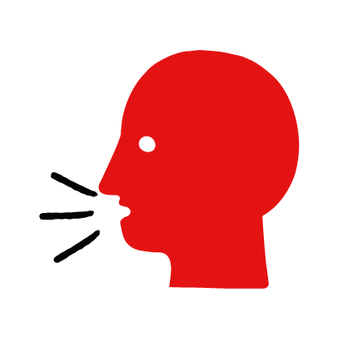

Discussion and film

Learning objectives
What you need
Strain or sprain interactive activity (images and text) on the strains and sprains first aid skill page

Learner skill guide ‘helping someone who has a strain or sprain’

- Learn how to recognise when someone has a strain or sprain.
- Learn the key action to help when someone has a strain or sprain.

Overview
Young people learn about strains and sprains, what they are and what happens when someone has one. They then learn the steps to helping and the key action to take when someone has a strain or sprain, so that they are more able, willing and confident to help.

Preparation
Ensure you can access the First aid champions website and can move through the interactive activity on the strains or sprains first aid skill page. Display or print off the Learner skill guide ‘helping someone who has a strain or sprain’.

Familiarise learners with the ground rules for the session or establish ground rules. For guidance on how to do that, see the Creating a safe, inclusive and supportive learning environment guidance.

How to run the activity

- Ask young people:
- What is a strain or a sprain?
A strain is when a muscle is damaged. A sprain is when a joint, such as an ankle, is damaged.
- What happens when someone has a strain or sprain?
They happen when someone suddenly moves part of their body. They may have pain, swelling or bruising around a joint or muscle.
- What can you do to help someone who has a strain or sprain?
Explain that in the next part of the activity the group are going to learn how to help someone who has a strain or sprain.
- Now go to the strains or sprains first aid skill page. Display the interactive activity on the web page, this will appear as a series of slides you can work through with the group. Alternatively, you could set the group up with individual or shared screens to work through the activity.
- Display or direct the group to the confidence slider on the strains or sprains first aid skill page, either setting this as an individual task or discussing group. How confident do learners feel to help someone who is has strain or sprain?
- On the strains or sprains first aid skill page, move through Lily’s story, displayed as a series of images and text. You could ask learners to read out the slides. After showing the story, ask young people:
- What was happening in Lily’s story? They were skating and Lily fell off her skateboard.
- How did they recognise their Lily had sprained her ankle? The ankle felt really sore and started to swell.
- How might they have felt? Think about the person who has the strain or sprain, the people who helped and anyone else nearby. They might say things like worried, in pain but also things like ready to help, glad their friends were there.
- What is the action that Lily’s friends took to help? Fetched a bag of cold peas, wrapped in a t-shirt, to put on Lily’s ankle.
- What else were they good at? What qualities did they show? They might say things like calm under pressure, caring and kind.

Questions learners might ask

Learners might have questions about this skill. Remember to provide an anonymous question box for questions they wish to ask privately. The key skills are the most important things they should remember, but you can find some extra information which might help you answer their questions here:
- How can I tell if someone has a strain or sprain?
Strains and sprains happen when someone suddenly moves part of their body. They may have pain, swelling or bruising around a joint or muscle. If the injury is at joint, the person may have difficulty in moving a limb.
- What’s the difference between a strain and a sprain?
A strain is when a muscle is damaged. A sprain is when a joint, such as knee, ankle or wrist, is damaged.
- What do I do after I have put an ice pack on the injury?
Keep the injured part of the body supported in a raised position.
- Should I call 999 for a strain or sprain?
Most strains and sprains will feel better after rest and cooling. Seek medical advice if you suspect that the bone is broken, there are other injuries, or the injury does not improve.

- Display or hand out the Learner skill guide ‘helping someone who has a strain or sprain’. In small groups, or as a whole group look at the learner skill guide and discuss again some of the signs of a strain or sprain and the key actions to help.
- Direct the group to the confidence slider on the strains or sprains first aid skill page and complete it again.
- Check what learners have learned by doing the strains or sprains reaction quiz.

Stretch and challenge activities:
- Ask learners to explain or write down the key steps to help someone who with a strain or sprain. They could create a diagram to show what someone who has a strain or sprain might look like and the key actions someone helping should do.
- Compare their work to the photos of the webpage, did they miss anything? Could they add details of how someone can help support the person who has a strain or sprain emotionally too.

Summing up
- Remind the group that the most important thing to do is cool the injury.
- Now practise how to help someone who has a strain or sprain with the practise activity.

