4.Burns
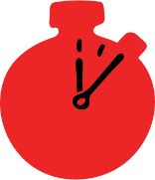
Group size

Whole group or small groups
Suggested timing

30 minutes
Method
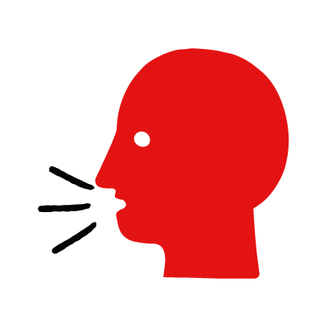

Discussion and film

Learning objectives
What you need
Burn interactive activity (images and text) on the burns first aid skill page

Learner skill guide ‘helping someone who has a burn’

- Learn how to recognize when someone has a burn.
- Learn the key action to help when someone has a burn.

Overview
Young people learn about burns, what they are and what happens when someone is experiencing one. They then learn the steps to helping and the key action to take when someone has a head injury so that they are more able, willing and confident to help.

Preparation
Ensure you can access the First aid champions website and can move through the interactive pages on the burns first aid skill page. Display or print off the Learner skill guide ‘helping someone who has a burn.

Familiarise learners with the ground rules for the session or establish ground rules. For guidance on how to do that, see the Creating a safe, inclusive and supportive learning environment guidance.

How to run the activity

- Start with these questions to establish current learning and to open the topic. Ask young people:
- What happens when someone has a burn? The person might have redness and severe pain after coming into contact with something hot. It may also start to blister.
- What could cause someone to have a burn? Burns are caused by something hot coming into contact with the skin. It could be a hot surface – such as an oven or hair straighteners, or a hot liquid – such as hot water from the kettle or a hot drink.
- What feelings might there be when someone has a burn? It can be very worrying when someone has a burn. It is okay to feel worried, the most important thing to do is to act quickly and calmly to help them.
- What can they do to help someone who is has a burn? Explain that in the next part of the activity the group are going to learn how to help someone who has a burn.
- Now go to the burns first aid skill page. Display the interactive activity on the web page, this will appear as a series of slides you can work through with the group. Alternatively, you could set the group up with individual or shared screens to work through the activity.
- Display or direct the group to the confidence slider on the burns first aid skill page, either setting this as an individual task or discussing as a group. How confident do learners feel to help someone who has a burn?
- On the burn first aid skill page, watch Sam’s film.* After showing the story, ask young people:
- What was happening in Sam’s story? Sam is at her friend’s house for a BBQ and gets burned.
- What caused Sam’s burns? She got lighter fluid on her hands and they got burned by the BBQ flames.
- What did Sam’s friends do to help? Someone put the fire out, her friend Joe got the hose and cooled the burn with water and Tash covered the burns in a clean plastic bag.
- How might they have felt? Think about the person with the burn, the person who helped and anyone else nearby. They might say things like worried, scared or in pain, but also things like calm and ready to help.
- What is the key action that Sam’s friends took to help? Run the burn under cool water for at least 20 minutes.
- What else were they good at? What qualities did they show? They might say things like, calm under pressure, quick to act, kind and caring, or brave.
*The end of the film has the question “What would you do?” this is a rhetorical device only. You do not need to ask learners to share what they would do in this situation.
- Show the short-animated film which appears in the activity on the last slide of the burn first aid skill page, this shows what happens in the body when someone has a burn.

Questions learners might ask

Learners might have questions about this skill. Remember to provide an anonymous question box for questions they wish to ask privately. The key skills are the most important things they should remember, but you can find some extra information which might help you answer their questions here:
- If clothes are stuck to the burn, should I try to remove them?
No. Remove any clothing or jewellery near the burned area, but don’t try to remove anything that’s stuck to the burn. This could cause more damage.
- What types of burns are there?
Burns fall into two main categories: burns and scalds. Burns are caused by contact with hot objects or flames, or by friction (for example, rope burns). Scalds are caused by steam or hot liquids, such as tea or oil. Both burns and scalds should be treated in exactly the same way. Other types of burns like chemical and electrical burns can also be treated the same way, but you must call 999 immediately after these burns. Sunburn and cold burns (like from ice) need to be treated differently.
- I’ve heard you can put butter/cream/toothpaste/ice etc. on a burn to treat it?
Only use cool safe liquids to treat a burn, ideally water. If you don’t have water you can still use other drinks milk, orange juice or even fizzy drinks and alcohol.

- Display or hand out the Learner skill guide ‘helping someone who is has a burn’. In small groups, or as a whole group look at the learner skill guide and discuss again some of the causes of burns and what someone would do to help.
- Direct the group to the confidence slider on the burn first aid skill page and complete it again.
- Check what learners have learned by doing the burns quiz.

Stretch and challenge activities:
- Ask learners to explain or write down the key steps to help someone who has a burn. They could create a diagram to show what someone having a burn might look like and the key actions someone helping should do.
- Compare their work to the photos of the webpage, did they miss anything? Could they add details of how someone can help support the person who has a burn emotionally too.

Summing up
- Remind the group that the most important thing to do is cool the burn under cold running water for at least 20 minutes.
- Now practise how to help someone who has a burn with the practise activity.

