9.Meningitis
Group size

Whole group or small groups
Suggested timing

30 minutes
Method
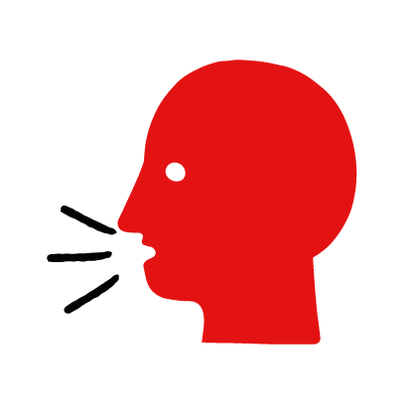

Discussion and film

Learning objectives
What you need
Meningitis interactive activity (images and text) on the meningitis first aid skill page

Learner skill guide ‘helping someone who has meningitis’

- Learn first aid skills and about basic treatment for common injuries
- Feel confident to help someone who needs first aid
- Learn about helping others and kindness

Overview
Young people learn about meningitis, what it is and what happens when someone is experiencing it. They then learn the steps to helping and the key action to take when someone has meningitis.

Preparation
Ensure you can access the First aid champions website and can move through the interactive activity on the meningitis first aid skill page. Display or print off the Learner skill guide ‘helping someone who has meningitis’.

How to run the activity

- Ask young people:
- What is a meningitis?
Meningitis is an illness where the surroundings of the brain and spinal cord swell up. It can happen to anyone at any age.
- What happens when someone has meningitis?
The person may have flu-like symptoms, a headache and a high temperature. They may also complain of a stiff neck and be sensitive to the light.
- Do you know of anyone who has ever had meningitis?
Make sure young people know they don’t need to share if they find a story upsetting, but if they want to share, explain that they are going to learn how to help someone who has meningitis.
- What feelings might there be when someone has meningitis?
It can be very worrying when someone has meningitis. It is okay to feel worried, the most important thing to do is to recognise what is happening and to calmly help them.
- What can you do to help someone who you think may have meningitis?
Explain that in the next part of the activity the group are going to learn how to help someone who has meningitis.
- Now go to the meningitis first aid skill page. Display the interactive activity on the web page, this will appear as a series of slides you can work through with the group. Alternatively, you could set the group up with individual or shared screens to work through the activity.
- Display or direct the group to the confidence slider on the meningitis first aid skill page, either setting this as an individual task or discussing as a group. How confident do learners feel to help someone who has meningitis?
- On the meningitis first aid skill page, move through Sarah’s story, displayed as a series of images and text. You could ask learners to read out the slides. After showing the story, ask young people:
- What was happening in Sarah’s story?
- How did Sarah recognise Liv may have meningitis?
- How might they have felt? Think about the person with meningitis and the people who helped.
- What is the action that Liv’s friends took to help? What were they good at? What qualities did they show? What can you learn from this? How could you use it?
- Direct the group to the confidence slider on the meningitis first aid skill page and complete it again.
- Display or hand out the Learner skill guide ‘helping someone who is has meningitis’. In small groups, or as a whole group look at the learner skill guide and discuss again some of the signs of meningitis and what they would do to help.
- Individually, or in small groups, choose one of the creative tasks below to complete the activity:
- Write or create a poster of how to recognise meningitis and the key action to take when someone has meningitis.
- Create your own meningitis story. They could map this out in pictures that they take as a group with text alongside, like in Sarah’s story, or just write text. They can create their story as a PowerPoint or as a short animation. Ensure that young people show the key action to take to help someone who has meningitis and get this across as part of their story. They can then share with the rest of the group – time allowing.

Summing up
- Remind the group that the most important thing to do is to help.
- Now practise how to help someone who has meningitis.

