1. The bystander effect in action
Group size
Small groups
Suggested timing

25 minutes
Method

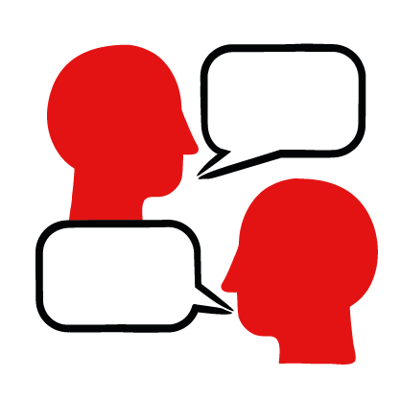

Discussion, film and article
What you need

Film

Newspaper article

Learning objectives
- Explain what the bystander effect is
- Evaluate how people respond in a first aid situation
- Create advice for challenging the bystander effect

Overview
Watch a film and read a newspaper article that show the bystander effect in action. Discuss the impact of the bystander effect and what learners can do to overcome it.

Preparation
Be able to play the film, and share the newspaper articles, either on screen or by printing them out.
Familiarise learners with the ground rules for the session or establish ground rules. Assure learners are given opportunities to ask questions and have a way to ask anonymous questions if they wish to. For guidance on how to do these things, see the Creating a safe, inclusive and supportive learning environment guidance.

Delivering the activity
- Begin by asking learners to share the definition of a ‘bystander’ – they should have covered this in the previous learn activity.
- Invite learners to watch the ‘What is the bystander effect – immersive experience’ film.
The film shows actors on a train, one man collapses and the video shows the points of view of three passengers and their thoughts in relation to the collapsed man. In the end one passenger does step forward to help, and that encourages the others to help too – this is an example of the bystander effect and what happens when one person overcomes it. It is 3 minutes long.
- Explain that this is a fictional scenario that’s based on real life events where the bystander effect has taken place, but has also been overcome. Ask them to think about:
- How can you see the bystander effect in action in this film?
- What reasons did the people have for not helping?
- What else do you think influenced their decision not to help?
- How do you think they overcame their worries?
- Why do you think everyone helped at the end once one person stepped forward?
- Finish the lesson by having learners highlight the key ways we can overcome the bystander effect to become helpers in a first aid situation. They could create a poster to describe what the bystander effect is and how we can overcome it – this could be things like, learn first aid skills to feel more able to help, don’t assume the person is sleeping or drunk, call 999 if it’s not safe to step in or step in to help and others will probably follow.

Stretch and challenge activities:
- Show learners another example of the bystander effect in action. Print out or display this newspaper case study https://www.bbc.co.uk/news/uk-england-london-57527492
This article discusses a man who was vomiting early one morning on a bench. Many people walked by assuming he was drunk or hungover from the night before. One woman stopped because she recognised the signs of a stroke.
- Ask learners to read the newspaper article. Working in pairs, ask learners to summarise the article and the key points back to the whole group.
- Use the suggested prompt questions below to support discussion around the article. Prompt questions:
- What is happening in the article?

- How do people react to the man?

- What influenced the woman to step forward to help?

- What might the people be thinking as they walk past the man in the article? Do you think his wife is correct when she says “Many probably assumed he was drunk or hungover”? Why might they have thought that?

- Are there any other reasons that they might not have intervened? Think about the time, early morning, could they have been rushing to work? Think about the coronavirus pandemic, is safety a concern?

- Think about the location, Mayfair is a wealthy but busy area of London. Do you think things would be different in a different place?

- Think about this article and the previous video. What similarities and differences are there in the stories?

Summing up
Invite learners to discuss the bystander effect, what have they learned?

Move on to Choosing to help skill page to continue exploring the bystander effect and ways to help others.

