3.Broken bone
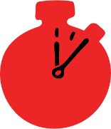
Group size

Whole group or small groups
Suggested timing

30 minutes
Method
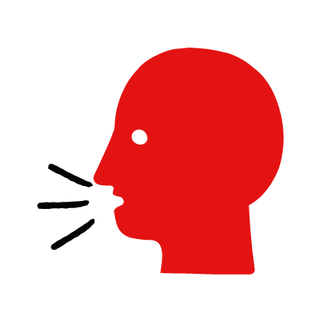

Discussion and film

Learning objectives
What you need
Broken bone interactive activity (images and text) on the broken bone first aid skill page

Learner skill guide ‘helping someone who has a broken bone’

- Learn how to recognise when someone may have a broken bone.
- Learn the key action to help when someone may have a broken bone.

Overview
Young people learn about broken bones, what they are and what happens when someone is experiencing one. They then learn the steps to helping and the key action to take when someone has a broken bone, so that they are more able, willing and confident to help.

Preparation
Ensure you can access the First aid champions website and can move through the interactive activity on the broken bone first aid skill page. Display or print off the Learner skill guide ‘helping someone who has a broken bone’.

Familiarise learners with the ground rules for the session or establish ground rules. For guidance on how to do that, see the Creating a safe, inclusive and supportive learning environment guidance.

How to run the activity

- Ask young people:
- What could cause someone to break a bone?
Broken bones can be caused by a fall or a blow from an object.
- How could you tell if someone has a broken bone?
They may be in pain, have bruising and swelling or be lying in an unnatural position. It can be very difficult to tell if a bone is broken – usually an X-Ray is needed.
- What feelings might there be when someone has a broken bone?
It can be very worrying when someone has a broken bone. It is okay to feel worried, the most important thing to do is to recognise what is happening and to calmly help them.
- What can you do to help someone who you think has a broken bone?
Explain that in the next part of the activity the group are going to learn how to help someone who has a broken bone.
- Now go to the broken bone first aid skill page. Display the interactive activity on the web page, this will appear as a series of slides you can work through with the group. Alternatively, you could set the group up with individual or shared screens to work through the activity.
- Display or direct the group to the confidence slider on the broken bone first aid skill page, either setting this as an individual task or discussing as a group. How confident do learners feel to help someone who has a broken bone?
- On the broken bone first aid skill page, move through Rose’s story, displayed as a series of images and text. You could ask learners to read out the slides. After showing the story, ask young people:
- What was happening in Rose’s story? Lara slipped and fell down the stairs on the way out of work.
- What caused Lara’s broken bone? She slipped and landed on her arm.
- How might they have felt? Think about the person with the broken bone, the person who helped and anyone else nearby. They might say things like worried, shocked or upset but also things like ready to help.
- What are the actions that Lara’s friends took to help her? Supported the broken arm and called 999.
- What else were they good at? What qualities did they show? They might say things like quick to act, or kind.

Questions learners might ask
Learners might have questions about this skill. Remember to provide an anonymous question box for questions they wish to ask privately. The key skills are the most important things they should remember, but you can find some extra information which might help you answer their questions here:
- What should I do if they won’t let me touch it?
Reassure them and encourage them to help them keep it still themselves.
- If they can move it or stand on it, does that mean it’s probably not broken?
Not necessarily. It could still be broken. The only way to know for sure is to get an x-ray. It is better to be too careful than not careful enough. Supporting the injury will help it feel less painful even if it is not broken. The hospital will then know how to fix it properly.
- If a bone is dislocated, should I put it back in place?
No. If there is a dislocation or the limb looks broken, the person needs to go to hospital for treatment. Never attempt to put dislocations back in place; you may cause further damage.
- What should I do if I think they’ve broken their collar bone?
For all broken bones you should follow the same treatment. If they have broken their collar bone they are likely to have pain if they move their arm (as it is attached to the collar bone). So help them to keep their arm still and supported with cushions, clothing or whatever you have to hand.
- Display or hand out the Learner skill guide ‘helping someone who has a broken bone’. In small groups, or as a whole group look at the learner skill guide and discuss again some of the signs of a broken bone and the key actions to help.
- Direct the group to the confidence slider on the broken bone first aid skill page and complete it again.
- Check what learners have learned by doing the broken bone quiz.

Stretch and challenge activities:
- Ask learners to explain or write down the key steps to help someone who has a broken arm. They could create a diagram to show what someone with a broken bone might look like and the key actions someone helping should do.
- Compare their work to the photos of the webpage, did they miss anything? Could they add details of how someone can help support the person who has a broken bone emotionally too?

Summing up
- Remind the group that the most important thing to do is support the injury.
- Now practise how to help someone who has a burn with the practise activity.

