12.Severe allergic reaction
Group size

Whole group or small groups
Suggested timing

30 minutes
Method
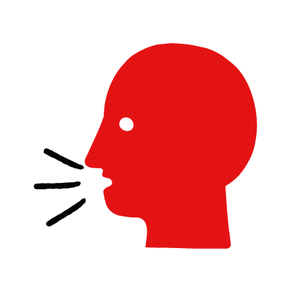

Discussion and film

Learning objectives
What you need
Severe allergic reaction interactive activity (images and text) on the severe allergic reaction first aid skill page

Learner skill guide ‘helping someone who is having a severe allergic reaction’

- Learn how to recognise when someone is having a severe allergic reaction.
- Learn the key action to help when someone is having a severe allergic reaction.

Overview
Young people learn about severe allergic reactions, what they are and what happens when someone is experiencing one. They then learn the steps to helping and the key action to take when someone is having a severe allergic reaction, so that they are more able, willing and confident to help.

Preparation
Ensure you can access the First aid champions website and can move through the interactive activity on the severe allergic reaction first aid skill page. Display or print off the Learner skill guide ‘helping someone who is having a severe allergic reaction’.

Familiarise learners with the ground rules for the session or establish ground rules. For guidance on how to do that, see the Creating a safe, inclusive and supportive learning environment guidance.

How to run the activity

- Ask young people:
- What can cause a severe allergic reaction?
Someone could have a severe allergic reaction if they come into contact with something that they have a severe allergy to. It could be food, such as nuts or shellfish or other triggers such as insect stings or latex.
- What happens when someone has a severe allergic reaction?
They may develop a rash, itchiness or swelling on their hands, feet or face. Their breathing may slow down.
- What feelings might there be when someone is having a severe allergic reaction?
It can be very worrying when someone is having a severe allergic reaction. It is okay to feel worried, the most important thing to do is to recognise what is happening and to act quickly and calmly to help them.
- What can you do to help someone who is having a severe allergic reaction?
Explain that in the next part of the activity the group are going to learn how to help someone who is having a severe allergic reaction.
- Now go to the severe allergic reaction first aid skill page. Display the interactive activity on the web page, this will appear as a series of slides you can work through with the group. Alternatively, you could set the group up with individual or shared screens to work through the activity.
- Display or direct the group to the confidence slider on the severe allergic reaction first aid skill page, either setting this as an individual task or discussing as a group. How confident do learners feel to help someone who is having a severe allergic reaction?
- On the severe allergic reaction first aid skill page, move through Finn’s story, displayed as a series of images and text. You could ask learners to read out the slides. After showing the story, ask young people:
- What was happening in Finn’s story?
- How did Joanna recognise Finn was having a severe allergic reaction?
- What did Joanna do to help?
- How might they have felt? Think about the person having the severe allergic reaction, the person who helped and anyone else nearby.
- What is the action that Joanna took to help? What else were they good at? What qualities did they show? What can you learn from this? How could you use it?

Questions learners might ask

Learners might have questions about this skill. Remember to provide an anonymous question box for questions they wish to ask privately. The key skills are the most important things they should remember, but you can find some extra information which might help you answer their questions here:
- How can I get an insect sting out of someone’s skin?
If the sting is still in the skin, brush or scrape it off sideways with your fingernail or an ID card. After the sting has been removed. Apply something cold to the area, (like an ice pack) to reduce the pain and swelling. This may not reduce the risk of an allergic reaction if someone has an allergy to stings.
- How will I know if it is a severe allergic reaction?
The person may have mild allergies, resulting in itchy skin and eyes. If they have a severe allergic reaction they might also have symptoms such as swelling of the tongue or neck and difficulty breathing. Call 999 if you notice these symptoms.
- I’ve heard of anaphylaxis/ anaphylactic shock, what is that?
These are names for a severe allergic reaction that makes it difficult for a person to breathe. If a doctor identifies someone as being at risk of anaphylactic shock, the may give them an auto-injector.
- What is an auto-injector? How do you use one?
Sometimes they are referred to as “Epi pens”. Auto-injectors contain medicine that can help someone who is having a severe allergic reaction by making it easier for them to breathe. They have instructions on the side to tell you how to use them if the person is unable to use it themselves.

- Display or hand out the Learner skill guide ‘helping someone who is having a severe allergic reaction’. In small groups, or as a whole group look at the learner skill guide and discuss again some of the signs of a severe allergic reaction and the key actions to help.
- Direct the group to the confidence slider on the severe allergic reaction first aid skill page and complete it again.
- Check what learners have learned by doing the severe allergic reaction quiz.

Stretch and challenge activities:
- Ask learners to explain or write down the key steps to help someone who is having a severe allergic reaction. They could create a diagram to show what someone who is having a severe allergic reaction might look like and the key actions someone helping should do.
- Compare their work to the photos of the webpage, did they miss anything? Could they add details of how someone can help support the person who is having a severe allergic reaction emotionally too.

Summing up
- Remind the group that the most important thing to do is to help the person use their auto-injector.
- Now practise how to help someone who is having a severe allergic reaction with the practise activity.

