15.Unresponsive and breathing
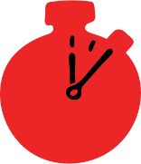
Group size

Whole group or small groups
Suggested timing

30 minutes
Method
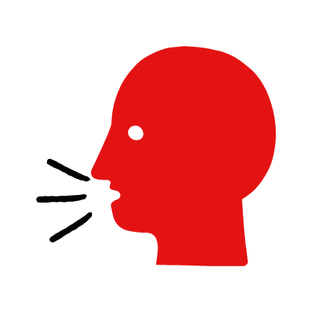

Discussion and film

Learning objectives
What you need
Unresponsive and breathing interactive activity (images and text) on the unresponsive and breathing first aid skill page

Learner skill guide ‘helping someone who is unresponsive and breathing’

- Learn how to recognize when someone is unresponsive and breathing.
- Learn the key action to help when someone is unresponsive and breathing.

Overview
Young people learn about someone who is unresponsive and breathing and what this means. They then learn the steps to helping and the key action to take when someone is unresponsive and breathing, so that they are more able, willing and confident to help.

Preparation
Ensure you can access the First aid champions website and can move through the interactive activity on the unresponsive and breathing first aid skill page. Display or print off the Learner skill guide ‘helping someone who is unresponsive and breathing’.

Familiarise learners with the ground rules for the session or establish ground rules. For guidance on how to do that, see the Creating a safe, inclusive and supportive learning environment guidance.

How to run the activity

- Ask young people:
- What does unresponsive mean? This is when someone is not moving and doesn’t respond when you call their name or tap their shoulders. If it is an adult who is unresponsive, you may need to shake their shoulders or tap harder.
- How can you check if someone is breathing? Tilt their head back and look at their chest or stomach to see if it is moving. Listen for breaths and feel for them on your cheek. If they are breathing, their chest or stomach will move. You should also hear or feel signs of breathing.
- What feelings might there be when someone is unresponsive and breathing? It can be very worrying when someone is unresponsive and breathing. It is okay to feel worried, the most important thing to do is to recognise what is happening and to calmly help them.
- What can you do to help someone who is unresponsive and breathing? Explain that in the next part of the activity the group are going to learn how to help someone who is unresponsive and breathing.
- Now go to the unresponsive and breathing first aid skill page. Display the interactive activity on the web page, this will appear as a series of slides you can work through with the group. Alternatively, you could set the group up with individual or shared screens to work through the activity.
- Display or direct the group to the confidence slider on the unresponsive and breathing first aid skill page, either setting this as an individual task or discussing group. How confident do learners feel to help someone who is unresponsive and breathing?
- On the unresponsive and breathing first aid skill page, watch Raheem’s story. After showing the story, ask young people:
- What was happening in Raheem’s story? They were drinking to celebrate finishing their exams and found Mark unresponsive and breathing in the bathroom.
- How did they recognise Mark wasn’t okay? He was lying on the floor and wouldn’t wake up.
- How might Raheem and Sophie have felt? They might say things like worried, or scared but also things like, determined to do something, ready to help him.
- What is the action that Mark’s friends took to help? Rolled him onto his side and tilt his head back.
- What else were they good at? What qualities did they show? They might say things like calm under pressure or sensible.
*The end of the film has the question “What would you do?” this is a rhetorical device only. You do not need to ask learners to share what they would do in this situation.
- Show the short-animated film which appears in the macro on the last slide of the unresponsive and breathing first aid skill page, this shows what happens in the body when someone is unresponsive and breathing.

Questions learners might ask
Learners might have questions about this skill. Remember to provide an anonymous question box for questions they wish to ask privately. The key skills are the most important things they should remember, but you can find some extra information which might help you answer their questions here:
- Why do I have to tilt their head back to check for breathing?
When a person is unresponsive, their muscles relax and their tongue can fall backwards and block their airway. Tilting their head back pulls their tongue forward and unblocks their airway which may be enough to help them to breathe.
- What do I do if the unresponsive person’s breathing doesn’t seem normal?
Sometimes when a person is unresponsive their breathing may become noisy or irregular. This is usually a sign that their heart and lungs are not working properly. If a person is unresponsive and they have noisy or irregular breathing or are gasping, treat them as an unresponsive person who is not breathing.
- Is it called the “recovery position” when you move a person onto their side and tilt their head back?
Yes, you can call it the “recovery position”.
- What should I do if someone is feeling faint?
If someone is feeling faint, advise them to lie down on their back and raise their legs to improve blood flow to the brain. Fainting is caused by a temporary reduction in the flow of blood to the brain and can result in becoming unresponsive for a brief period of time. A person who has fainted should quickly become responsive again. If they don’t treat them as an unresponsive person.

- Display or hand out the Learner skill guide ‘helping someone who is unresponsive and breathing’. In small groups, or as a whole group look at the learner skill guide and discuss again how they can identify if someone is unresponsive and breathing and the key actions to help.
- Direct the group to the confidence slider on the unresponsive and breathing first aid skill page and complete it again.
- Check what learners have learned by doing the unresponsive and breathing quiz.

Stretch and challenge activities:
- Ask learners to explain or write down the key steps to help someone who is unresponsive and breathing. They could create a diagram to show what someone who is unresponsive and breathing might look like and the key actions someone helping should do.
- Compare their work to the photos of the webpage, did they miss anything? Could they add details of how someone can help support the person who is unresponsive and breathing emotionally too.

Summing up
- Remind the group that the most important thing to do is to roll them on their side and tilt their head back.
- Now practise how to help someone who is unresponsive and breathing with the practise activity.

