17.Unresponsive and not breathing (AED)
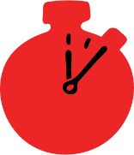
Group size

Whole group or small groups
Suggested timing

30 minutes
Method
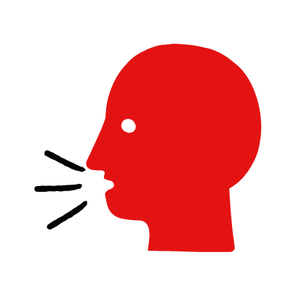

Discussion and film

Learning objectives
What you need
Unresponsive and not breathing (AED) interactive activity (images and text) on the unresponsive and not breathing (AED) first aid skill page

Learner skill guide ‘helping someone who is unresponsive and not breathing (AED)’

- Learn how to recognize when someone is unresponsive and not breathing when an AED is available.
- Learn the key action to help when someone is unresponsive and not breathing when an AED is available.

Overview
Young people learn about someone who is unresponsive and not breathing and what this means and what an AED is. They then learn the steps to helping and the key action to take when someone is unresponsive and not breathing and there is an AED available, so that they are more able, willing and confident to help.

Preparation
Ensure you can access the First aid champions website and can move through the interactive pages on the unresponsive and not breathing (AED) first aid skill page. Display or print off the Learner skill guide ‘helping someone who is unresponsive and not breathing (AED)’.

Familiarise learners with the ground rules for the session or establish ground rules. For guidance on how to do that, see the Creating a safe, inclusive and supportive learning environment guidance.

How to run the activity

- Ask young people:
- What does unresponsive mean? This is when someone is not moving and doesn’t respond when you call their name or tap their shoulders. If it’s an adult who is unresponsive you might need to tap harder or shake their shoulders.
- How can they check if someone is breathing? Tilt their head back and look at their chest or stomach to see if it is moving. Listen for breaths and feel for them on your cheek. If they are not breathing, their chest or stomach will not move. You won’t hear or feel signs of breathing.
- What is an AED? AED stands for automated external defibrillator. It is a machine that can shock someone’s heart if it’s not working properly. The AED will only shock someone if they need it – it will never shock a healthy heart. It gives instructions on how to use it so anyone can use it.
- Have you ever seen an AED? Where? AEDs are available in lots of public places, such as train stations, shopping centres and schools.
- What feelings might there be when someone is unresponsive and not breathing? It can be very worrying when someone is unresponsive and not breathing. It’s okay to feel worried, the most important thing to do is to act quickly to help them and try to stay calm.
- What can you do to help someone who is unresponsive and not breathing when an AED is available? Explain that in the next part of the activity the group are going to learn how to help someone who is unresponsive and not breathing when an AED is available.
- Now go to the unresponsive and not breathing (AED) first aid skill page. Display the interactive activity on the web page, this will appear as a series of slides you can work through with the group. Alternatively, you could set the group up with individual or shared screens to work through the activity.
- Display or direct the group to the confidence slider on the unresponsive and not breathing (AED) first aid skill page, either setting this as an individual task or discussing group. How confident do learners feel to help someone who is unresponsive and not breathing when an AED is available?
- On the unresponsive and not breathing (AED) first aid skill page, move through CJ’s story, displayed as a series of images and text. You could ask learners to read out the slides. After showing the story, ask young people:
- What was happening in CJ’s story? At the gym, he sees a man collapse and become unresponsive.
- How might CJ have felt? How might Joy and other people nearby have felt? They might say things like, worried, shocked but also things like ready to help, confident they knew what to do.
- What is the action that CJ took to help? He checked to see if he was breathing. He told his sister to call 999 and fetch and AED as he gave chest compressions.
- What else were they good at? What qualities did they show? They might say things like quick to act, helpful, kind.

Questions learners might ask
Learners might have questions about this skill. Remember to provide an anonymous question box for questions they wish to ask privately. The key skills are the most important things they should remember, but you can find some extra information which might help you answer their questions here:
- Why do I have to tilt their head back to check for breathing?
When a person is unresponsive, their muscles relax and their tongue can fall backwards and block their airway. Tilting their head back pulls their tongue forward and unblocks their airway which may be enough to help them to breathe.
- If I am alone, should I leave the person to get an AED?
Stay with them and give chest compressions (and rescue breaths if they are a child or if you feel confident to do so) Call out for help and send someone else to get the AED if they arrive.
- Will I restart the person’s heart if I use an AED?
If the AED delivers a shock to the person, it doesn’t always mean that their heart will restart. The machine will detect this and give you further instructions. You may need to resume chest compressions. Continue to follow the AED voice prompts until help arrives.
- Can I use an AED on a child?
Yes you can use an AED on any child over the age of one year old. Of the child is aged between one and eight years, use the paediatric pads. If there are no paediatric pads available use the standard ones placing on in the centre of the child’s chest and the other in the centre of the child’s back.

- Display or hand out the Learner skill guide ‘helping someone who is unresponsive and not breathing when an AED is available’. In small groups, or as a whole group, look at the learner skill guide and discuss again how they can identify if someone is unresponsive and not breathing and the key actions to help when an AED is available.
- Check what learners have learned by doing the unresponsive and not breathing (AED) quiz.

Stretch and challenge activities:
- Ask learners to explain or write down the key steps to help someone who is unresponsive and not breathing when an AED is available. They could create a diagram to show what someone who is unresponsive and not breathing might look like and the key actions to help.
- Compare their work to the photos of the webpage, did they miss anything? Could they add details of how someone can help support the person who is unresponsive and not breathing emotionally too.

Summing up
- Remind the group that the most important thing to do is to give chest compressions and follow the voice prompts in the AED.
- Now practise how to help someone who is unresponsive and not breathing when an AED is available with the practise activity.

