7.Heart attack
Group size

Whole group or small groups
Suggested timing

30 minutes
Method
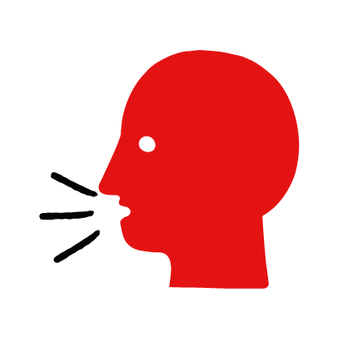

Discussion and film

Learning objectives
What you need
Heart attack interactive activity (images and text) on the heart attack first aid skill page

Learner skill guide ‘helping someone who is having a heart attack’

- Learn first aid skills and about basic treatment for common injuries
- Feel confident to help someone who needs first aid
- Learn about helping others and kindness

Overview
Young people learn about heart attacks, what they are and what happens when someone is experiencing one. They then learn the steps to helping and the key action to take when someone is having a heart attack.

Preparation
Ensure you can access the First aid champions website and can move through the interactive activity on the heart attack first aid skill page. Display or print off the Learner skill guide ‘helping someone who is having a heart attack’.

How to run the activity

- Ask young people:
- What is a heart attack?
A heart attack happens when the blood supply to someone’s heart is suddenly blocked. The blockage means the heart cannot work properly.
- What happens when someone has a heart attack?
They may have persistent, vice-like chest pain. The pain may spread to their arms, back, jaw or stomach.
- Have you ever seen someone having a heart attack? Possibly on TV or in a film?
Make sure young people know they don’t need to share if they find a story upsetting, but if they want to share, explain that they are going to learn how to help someone who is having a heart attack.
- What feelings might there be when someone is having a heart attack?
It can be very worrying when someone is having a heart attack. It is okay to feel worried, the most important thing to do is to recognise what is happening and to act quickly and calmly to help them.
- What could you do to help someone who is having a heart attack?
Explain that in the next part of the activity the group are going to learn how to help someone who is having a heart attack.
- Now go to the heart attack first aid skill page. Display the interactive activity on the web page, this will appear as a series of slides you can work through with the group. Alternatively, you could set the group up with individual or shared screens to work through the activity
- Display or direct the group to the confidence slider on the heart attack first aid skill page, either setting this as an individual task or discussing group. How confident do learners feel to help someone who is having a heart attack?
- On the heart attack first aid skill page, watch Jake’s film. After showing the story, ask young people:
- What was happening in Jake’s story?
- How did they recognise their coach was having a heart attack?
- How might they have felt? Think about the person having the heart attack, the people who helped and anyone else nearby.
- What is the action that Jake and his friends took to help? What were they good at? What qualities did they show? What can you learn from this? How could you use it?
- Direct the group to the confidence slider on the heart attack first aid skill page and complete it again.
- Display or hand out the Learner skill guide ‘helping someone who is having a heart attack’. In small groups, or as a whole group look at the learner skill guide and discuss again some of the signs of a heart attack and what they would do to help.
- Individually, or in small groups choose one of the creative tasks below to complete the activity:
- Write or create a poster of how to recognise a heart attack and the key action to take when someone is having a heart attack.
- Create your own heart attack story. They could map this out in pictures that they take as a group with text alongside, or just write text. They can create their story as a PowerPoint or as a short animation. Ensure that young people show the key action to take to help someone who is having a heart attack and get this across as part of their story. They can then share with the rest of the group – time allowing.

Summing up
- Remind the group that the most important thing to do is to help.
- Now practise how to help someone who is having a heart attack.

