2.Bleeding heavily
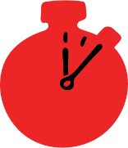
Group size

Whole group or small groups
Suggested timing

30 minutes
Method
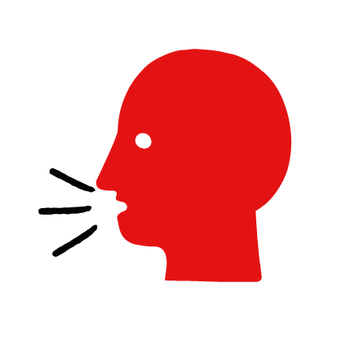

Discussion and film

Learning objectives
What you need
Bleeding heavily interactive activity (images and text) on the bleeding heavily first aid skill page

Learner skill guide ‘helping someone who is bleeding heavily’

- Learn how to recognise when someone is bleeding heavily.
- Learn the key action to help when someone is bleeding heavily.

Overview
Young people learn about bleeding, what could cause it and what happens when someone is bleeding. They then learn the steps to helping and the key action to take when someone is bleeding heavily, so that they are more able, willing and confident to help.

Preparation
Ensure you can access the First aid champions website and can move through the interactive activity on the bleeding heavily first aid skill page. Display or print off the Learner skill guide ‘helping someone who is bleeding heavily’.

Familiarise learners with the ground rules for the session or establish ground rules. For guidance on how to do that, see the Creating a safe, inclusive and supportive learning environment guidance.

How to run the activity

- Ask young people:
- What does it mean when someone is bleeding heavily?
When blood is flowing from a wound and it’s too big for a plaster.
- What could cause someone to be bleeding heavily?
The skin being cut with a sharp object, such as broken glass, barbed wire or a sharp knife.
- What feelings might there be when someone is bleeding heavily?
It would be very worrying when someone is bleeding; it is a life-threatening condition. It is okay for young people to feel worried, the most important thing is to act quickly and calmly try to help the person. You may need to explore how young people can keep themselves safe if they feel in danger.
- What can be done to help someone who is bleeding heavily?
Explain that in the next part of the activity the group are going to learn how to help someone who is bleeding heavily.
- Now go to the bleeding heavily first aid skill page. Display the interactive activity on the web page, this will appear as a series of slides you can work through with the group. Alternatively, you could set the group up with individual or shared screens to work through the activity.
- Display or direct the group to the confidence slider on the bleeding heavily first aid skill page, either setting this as an individual task or discussing as a group. How confident do learners feel to help someone who is bleeding heavily?
- On the bleeding heavily first aid skill page, watch Seb’s film. After showing the story, ask young people:
- What was happening in Seb’s story? He was jumping over some railings to get home because it was the quick route.
- How did Seb hurt his arm? He slipped and cut it on the razor wire on the railings.
- What did Hayley do to help? She used her new top to press hard on the wound.
- How might they have felt? Think about the person bleeding heavily, the person who helped and anyone else nearby. They might say things like, worried, scared but also ready to help and confident they knew what to do.
- What was the key action Hayley took to help? Put pressure on the wound.
- What qualities did Hayley show? They might say things like quick to act, selfless, kind.
*The end of the film has the question “What would you do?” this is a rhetorical device only. You do not need to ask learners to share what they would do in this situation.
- Show the short-animated film which appears in the activity of the bleeding heavily first aid skill page, this shows what happens in the body when someone is bleeding heavily.

Questions learners might ask

Learners might have questions about this skill. Remember to provide an anonymous question box for questions they wish to ask privately. The key skills are the most important things they should remember, but you can find some extra information which might help you answer their questions here:
- What about a nosebleed?
For a nosebleed, you need to lean your head forward and pinch the soft part of your nose. Do this for 10 minutes. If the nose is still bleeding after 30 minutes, seek medical advice.
- What should I do if there is an object in the wound? ​
Do not remove it it’s helping plug the hole and stop the blood flow. Instead, simply apply ​pressure around the object. Removing the object from the wound can make the bleeding ​much worse.
- If a person has been stabbed with a sharp object and has a deep wound, ​what should I do? ​
Tell someone to call 999 immediately while you help them sit down if they still standing. You can help them lean on their uninjured side if it helps them to breathe. If the wound is bleeding, then apply pressure to it to stop or slow down the flow of blood. If it is not bleeding, then leave the wound open to the air. Remember not to remove the object. If you are alone and there is no one around to help, put your phone on speaker to call for an ambulance while you help the person.
- What if the blood soaks through the towel/t-shirt etc?
Remove the old thing and replace it with a fresh one. Make sure that you press hard on the bleed and call 999 as soon as possible. If you can’t call 999 get someone ​else to do it.
- Should I wash it?
Don’t wash a cut that is bleeding a lot, it might make it bleed more. You can wash small cuts and grazes that just need a plaster, this will help keep it clean so it can heal healthily. You should wash animal bites that aren’t bleeding too much with soapy water.
- Display or hand out the Learner skill guide ‘helping someone who is bleeding heavily’. In small groups, or as a whole group, look at the learner skill guide and discuss again the key actions to help.
- Direct the group to the confidence slider on the bleeding heavily first aid skill page and complete it again.
- Check what learners have learned by doing the bleeding heavily quiz.

Stretch and challenge activities:
- Ask learners to explain or write down the key steps to help someone who is bleeding heavily. They could create a diagram to show what someone bleeding heavily might look like and the key actions someone helping should do.
- Compare their work to the photos of the webpage, did they miss anything? Could they add details of how someone can help support the person who is bleeding heavily emotionally too?

Summing up
- Remind the group that the most important thing to do is put pressure on the wound.
- Now practise how to help someone who has a burn with the practise activity.

