5.Choking
Group size

Whole group or small groups
Suggested timing

30 minutes
Method
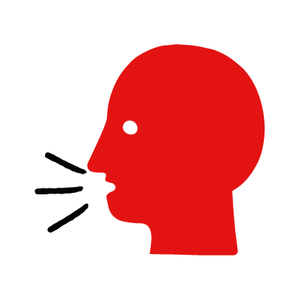

Discussion and film

Learning objectives
What you need
Choking interactive activity (images and text) on the choking first aid skill page

Learner skill guide ‘helping someone who is choking’

- Learn first aid skills and about basic treatment for common injuries
- Feel confident to help someone who needs first aid
- Learn about helping others and kindness

Overview
Young people learn about choking, what causes it and what happens when someone is choking. They then learn the steps to helping and the key action to take when someone is choking.

Preparation
Ensure you can access the First aid champions website and can move through the interactive activity on the choking first aid skill page. Display or print off the Learner skill guide ‘helping someone who is choking’.

How to run the activity

- Ask young people:
- What happens when someone is choking?
They will be unable to speak, cough or breathe. They may be clutching at their chest or neck.
- What causes someone to choke?
Choking is caused by a blockage in someone’s airway (the tube that they breathe through). It usually happens when eating, by food ‘going down the wrong way’.
- Have you ever choked or seen someone choking? What happened?
Make sure young people know they don’t need to share if they find a story upsetting, but if they want to share, explain that they are going to learn how to help someone who is choking.
- What feelings might there be when someone is choking?
It can be very worrying when someone is choking. It is okay to feel worried, the most important thing to do is to recognise what is happening and to act quickly and calmly to help them.
- What can you do to help someone who is choking?
Explain that in the next part of the activity the group are going to learn how to help someone who is choking.
- Now go to the choking first aid skill page. Display the interactive activity on the web page, this will appear as a series of slides you can work through with the group. Alternatively, you could set the group up with individual or shared screens to work through the activity.
- Display or direct the group to the confidence slider on the choking first aid skill page, either setting this as an individual task or discussing as a group. How confident do learners feel to help someone who is choking.
- On the choking first aid skill page, watch Amina’s film. After showing her story, ask young people:
- What was happening in Amina’s story?
- What caused Amina to start choking?
- How might they have felt? Think about the person choking, the person who helped and anyone else nearby.
- What is the action that Amina’s friend took to help her? What else was she good at? What qualities did she show? What can you learn from this? How could you use it?
- Show the short-animated film which appears in the macro on the last slide of the choking first aid skill page, this shows what happens in the body when someone is choking. Direct the group to the confidence slider on the choking first aid skill page and complete it again.
- Display or hand out the Learner skill guide ‘helping someone who is choking’. In small groups, or as a whole group look at the learner skill guide and discuss again some of the signs of choking and what they would do to help.
- Individually, or in small groups choose one of the creative tasks below to complete the activity:
- Write or create a poster of how to recognise someone is choking and the key action to take when someone is choking.
- Create your own choking story. They could map this out in pictures that they take as a group with text alongside, or just write text. They can create their story as a PowerPoint or as a short animation, ensure that young people show the key action to take to help someone who is choking and get this across as part of their story. They can then share with the rest of the group – time allowing.

Summing up
- Remind the group that the most important thing to do is to help.
- Now practise how to help someone who is choking.

