14.Stroke
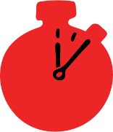
Group size

Whole group or small groups
Suggested timing

30 minutes
Method
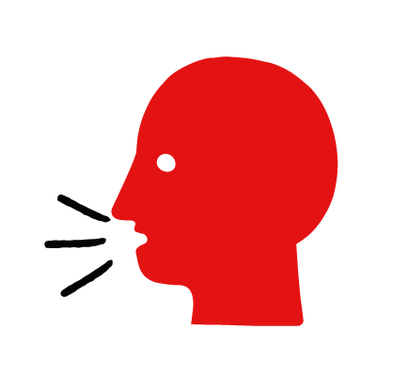

Discussion and film

Learning objectives
What you need
Stroke interactive activity (images and text) on the stroke first aid skill page

Learner skill guide ‘helping someone who is having a stroke’

- Learn first aid skills and about basic treatment for common injuries
- Feel confident to help someone who needs first aid
- Learn about helping others and kindness

Overview
Young people learn about strokes, what they are and what happens when someone has one. They then learn the steps to helping and the key action to take when someone is having a stroke.

Preparation
Ensure you can access the First aid champions website and can move through the interactive activity on the stroke first aid skill page. Display or print off the Learner skill guide ‘helping someone who is having a stroke’.

How to run the activity

- Ask young people:
- What is a stroke?
A stroke happens when there are problems with the blood supply to someone’s brain. This damages part of the brain which affects a person’s face, body functions, speech and sight.
- Have you ever seen someone having a stroke? Possibly on TV or in a film?
Make sure young people know they don’t need to share if they find a story upsetting, but if they want to share, explain that they are going to learn how to help someone who is having a stroke.
- What feelings might there be when someone is having a stroke?
It can be very worrying when someone has a stroke. It is okay to feel worried, the most important thing to do is to recognise what is happening and to act quickly and calmly to help them.
- What can you do to help someone who is having a stroke?
Explain that in the next part of the activity the group are going to learn how to help someone who is having a stroke.
- Now go to the stroke first aid skill page. Display the interactive activity on the web page, this will appear as a series of slides you can work through with the group. Alternatively, you could set the group up with individual or shared screens to work through the activity.
- Display or direct the group to the confidence slider on the stroke first aid skill page, either setting this as an individual task or discussing as a group. How confident do learners feel to help someone who is having a stroke?
- On the stroke first aid skill page, move through Anthony’s story, displayed as a series of images and text. You could ask learners to read out the slides. After showing the story, ask young people:
- What was happening in Anthony’s story?
- How did he recognise his granddad was having a stroke?
- How might they have felt? Think about the person having the stroke, the person who helped and anyone else nearby.
- What is the action that Anthony took to help? What else was he good at? What qualities did he show? What can you learn from this? How could you use it?
- Direct the group to the confidence slider on the stroke first aid skill page and complete it again.
- Display or hand out the Learner skill guide ‘helping someone who is having a stroke’. In small groups, or as a whole group look at the learner skill guide and discuss again some of the signs of a stroke and what they would do to help.
- Individually, or in small groups choose one of the creative tasks below to complete the activity:
- Write or create a poster of how to recognise a stroke and the key action to take when someone is having a stroke.
- Create your own stroke story. They could map this out in pictures that they take as a group with text alongside, like in Anthony’s story, or just write text. They can create their story as a PowerPoint or as a short animation. Ensure that young people show the key action to take to help someone who is having a stroke and get this across as part of their story. They can then share with the rest of the group – time allowing.

Summing up
- Remind the group that the most important thing to do is to help.
- Now practise how to help someone who is having a stroke.

