2. Head, heart, hands
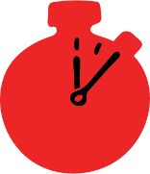
Group size
Small groups
Suggested timing

15-20 minutes
Method

Active learning
What you need

Pens and paper

Learning objectives
- Think about what motivates people to help others

Overview

Learners think about the thinking, feelings and actions of those who help others through drawing and writing.

Preparation
Learners will need paper, pens or pencils.

Delivering the activity
- Either individually or in small groups ask young people to draw an outline of a person.
- Ask learners to think about the confidence, skills and personal qualities that might be needed to help someone in need, this could be someone in need of first aid, or someone who looks like they need someone to ask how they are. They can write or draw their ideas inside the outline of their person, for example they could:
- Write or draw in the head, how they might think.
- Write or draw in the heart, how they might feel.
- Write or draw in the hands, how they might act or behave

Summing up
Invite learners to share their work, reflecting through group discussion on how these thoughts, feelings and actions might enable them and others to help someone in need.

