7.Heart attack
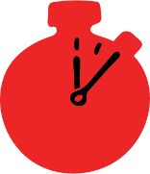
Group size

Whole group or small groups
Suggested timing

30 minutes
Method
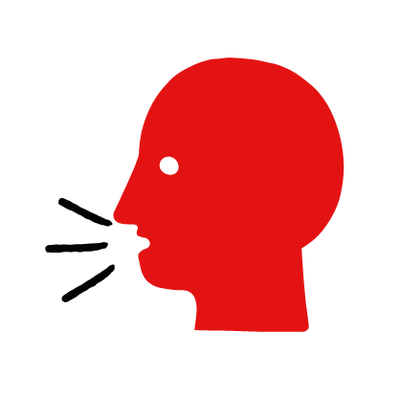

Discussion and film

Learning objectives
What you need
Heart attack interactive activity (images and text) on the heart attack first aid skill page

Learner skill guide ‘helping someone who is having a heart attack’

- Learn how to recognise when someone may be having a heart attack.
- Learn the key action to help when someone may be having a heart attack.

Overview
Young people learn about heart attacks, what they are and what happens when someone is experiencing one. They then learn the steps to helping and the key action to take when someone is having a heart attack, so that they are more able, willing and confident to help.

Preparation
Ensure you can access the First aid champions website and can move through the interactive activity on the heart attack first aid skill page. Display or print off the Learner skill guide ‘helping someone who is having a heart attack’.

Familiarise learners with the ground rules for the session or establish ground rules. For guidance on how to do that, see the Creating a safe, inclusive and supportive learning environment guidance.

How to run the activity

- Ask young people:
- What is a heart attack?
A heart attack happens when the blood supply to someone’s heart is suddenly blocked. The blockage means the heart cannot work properly.
- What happens when someone has a heart attack?
They may have persistent, vice-like chest pain. The pain may spread to their arms, back, jaw or stomach.
- What feelings might there be when someone is having a heart attack?
It can be very worrying when someone is having a heart attack. It is okay to feel worried, the most important thing to do is to recognise what is happening and to act quickly and calmly to help them.
- What could you do to help someone who is having a heart attack?
Explain that in the next part of the activity the group are going to learn how to help someone who is having a heart attack.
- Now go to the heart attack first aid skill page. Display the interactive activity on the web page, this will appear as a series of slides you can work through with the group. Alternatively, you could set the group up with individual or shared screens to work through the activity
- Display or direct the group to the confidence slider on the heart attack first aid skill page, either setting this as an individual task or discussing group. How confident do learners feel to help someone who is having a heart attack?
- On the heart attack first aid skill page, watch Jake’s film. After showing the story, ask young people:
- What was happening in Jake’s story? He was playing a football match when his coach suddenly had a heart attack.
- How did they recognise their coach was having a heart attack? He had a crushing pain in his chest, pain in his arm, that spread to his jaw.
- How might they have felt? Think about the person having the heart attack, the people who helped and anyone else nearby. They might say things like worried, confused, anxious, but also things like supported, happy to help.
- What is the action that Jake and his friends took to help? They sat him down and called 999.
- What were they good at? What qualities did they show? They might say things like calm under pressure and supportive.

Questions learners might ask
Learners might have questions about this skill. Remember to provide an anonymous question box for questions they wish to ask privately. The key skills are the most important things they should remember, but you can find some extra information which might help you answer their questions here:
- What is the difference between a heart attack and a cardiac arrest?
A cardiac arrest is when the heart stops working completely, causing the person to collapse, becoming unresponsive and stop breathing. A cardiac arrest may be caused by a heart attack.
- What if they have medication to use?
If they have tablets or a spray, let them take it. You may need to assist them.
- What is angina?
Angina is when the arteries narrow, restricting the blood supply to the heart. It is​ often associated with exercise or excitement. Symptoms include chest pain and ​shortness of breath but, unlike a heart attack, symptoms ease with rest and taking ​prescribed medication. Most people who have angina manage it with medication that​ comes in tablet or spray form. If, during an angina attack, the pain doesn’t subside ​after the second dose of their medication, suspect a heart attack and call 999 immediately. ​

- Display or hand out the Learner skill guide ‘helping someone who is having a heart attack’. In small groups, or as a whole group look at the learner skill guide and discuss again some of the signs of a heart attack and the key actions to help.
- Direct the group to the confidence slider on the heart attack first aid skill page and complete it again.
- Check what learners have learned by doing the heart attack quiz.

Stretch and challenge activities:
- Ask learners to explain or write down the key steps to help someone who is having a heart attack. They could create a diagram to show what someone who is having a heart attack might look like and the key actions someone helping should do.
- Compare their work to the photos of the webpage, did they miss anything? Could they add details of how someone can help support the person who is having a heart attack emotionally too.

Summing up
- Remind the group that the most important thing to do is to call 999.
- Now practise how to help someone who is having a heart attack.

