9.Meningitis
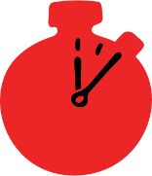
Group size

Whole group or small groups
Suggested timing

30 minutes
Method
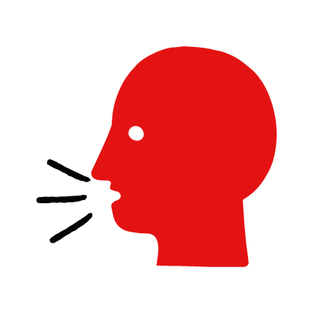

Discussion and film

Learning objectives
What you need
Meningitis interactive activity (images and text) on the meningitis first aid skill page

Learner skill guide ‘helping someone who has meningitis’

- Learn how to recognise when someone may have meningitis.
- Learn the key action to help when someone may have meningitis.

Overview
Young people learn about meningitis, what it is and what happens when someone is experiencing it. They then learn the steps to helping and the key action to take when someone has meningitis, so that they are more able, willing and confident to help.

Preparation
Ensure you can access the First aid champions website and can move through the interactive activity on the meningitis first aid skill page. Display or print off the Learner skill guide ‘helping someone who has meningitis’.

Familiarise learners with the ground rules for the session or establish ground rules. For guidance on how to do that, see the Creating a safe, inclusive and supportive learning environment guidance.

How to run the activity

- Ask young people:
- What is meningitis?
Meningitis is an illness where the surroundings of the brain and spinal cord swell up. It can happen to anyone at any age.
- What happens when someone has meningitis?
The person may have flu-like symptoms, a headache and a high temperature. They may also complain of a stiff neck and be sensitive to the light.
- What feelings might there be when someone has meningitis?
It can be very worrying when someone has meningitis. It is okay to feel worried, the most important thing to do is to recognise what is happening and to calmly help them.
- What can you do to help someone who you think may have meningitis?
Explain that in the next part of the activity the group are going to learn how to help someone who has meningitis.
- Now go to the meningitis first aid skill page. Display the interactive activity on the web page, this will appear as a series of slides you can work through with the group. Alternatively, you could set the group up with individual or shared screens to work through the activity.
- Display or direct the group to the confidence slider on the meningitis first aid skill page, either setting this as an individual task or discussing as a group. How confident do learners feel to help someone who has meningitis?
- On the meningitis first aid skill page, move through Sarah’s story, displayed as a series of images and text. You could ask learners to read out the slides. After showing the story, ask young people:
- What was happening in Sarah’s story? Sarah is revising with her friends, but Liv seems really ill.
- How did Sarah recognise Liv may have meningitis? She had a headache, her neck felt very sore and stiff and she was very sensitive to light.
- How might they have felt? Think about the person with meningitis and the people who helped. They might say things like worried, stressed but also things like ready help, sure of themselves.
- What is the action that Liv’s friends took to help? She checked on her first aid app what she should do, and then decided to call 999 rather than risk leaving it to get worse.
- What were they good at? What qualities did they show? They might say things like sensible, careful and supportive.

Questions learners might ask

Learners might have questions about this skill. Remember to provide an anonymous question box for questions they wish to ask privately. The key skills are the most important things they should remember, but you can find some extra information which might help you answer their questions here:
- What is meningitis?
Meningitis is an illness where the linings that surround the brain and spinal cord swell up. It can be caused by bacteria or viruses, and can happen to anyone at any age.
- Doesn’t meningitis give you a rash?
It does, but this will form at a later stage. The rash won’t disappear when a glass is pressed on it. Don’t wait until this symptom appears before calling 999. A person with meningitis can get worse very quickly and without proper treatment, can cause permanent damage.
- What does the rash look like?
The rash is made up of small red or purple “pin prick” spots that may spread to look like fresh bruising. The rash can be more difficult to see on dark skin. The rash will not disappear when a glass is pressed against it. Rashes usually appear in the later stages of meningitis and sometimes do not appear at all.
If the person has a rash, press the side of a clear glass against their skin. Most rashes will fade when pressed. If you can still see the rash through the glass, it may be meningitis.
- What is sepsis?
Sepsis is a life-threatening complication that can happen when the body is fighting an infection, causing damage to tissues and organs. There are many causes of sepsis, one of which is meningitis. It is usually older people or young children who are affected, although it can affect anyone, especially people with weakened immune systems. Signs of sepsis include many signs similar to meningitis and can also include feeling breathless or breathing very fast, speech becoming slurred or confused, and not weeing all day. If you suspect sepsis in someone of any age or if you are unsure, call 999.

- Display or hand out the Learner skill guide ‘helping someone who has meningitis’. In small groups, or as a whole group look at the learner skill guide and discuss again some of the signs of meningitis and they key actions to help.
- Direct the group to the confidence slider on the meningitis first aid skill page and complete it again.
- Check what learners have learned by doing the meningitis quiz.

Stretch and challenge activities:
- Ask learners to explain or write down the key steps to help someone who has meningitis. They could create a diagram to show what someone who has meningitis might look like and the key actions someone helping should do.
- Compare their work to the photos of the webpage, did they miss anything? Could they add details of how someone can help support the person who has meningitis emotionally too.

Summing up
- Remind the group that the most important thing to do is call 999.
- Now practise how to help someone who has meningitis with the practise activity.

