14.Stroke
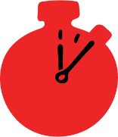
Group size

Whole group or small groups
Suggested timing

30 minutes
Method
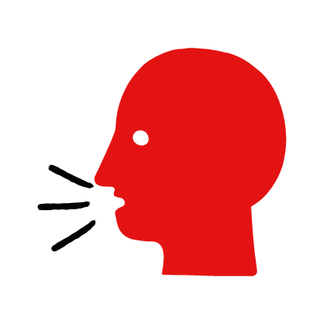

Discussion and film

Learning objectives
What you need
Stroke interactive activity (images and text) on the stroke first aid skill page

Learner skill guide ‘helping someone who is having a stroke’

- Learn how to recognise when someone is having a stroke.
- Learn the key action to help when someone is having a stroke.

Overview
Young people learn about strokes, what they are and what happens when someone has one. They then learn the steps to helping and the key action to take when someone is having a stroke, so that they are more able, willing and confident to help.

Preparation
Ensure you can access the First aid champions website and can move through the interactive activity on the stroke first aid skill page. Display or print off the Learner skill guide ‘helping someone who is having a stroke’.

Familiarise learners with the ground rules for the session or establish ground rules. For guidance on how to do that, see the Creating a safe, inclusive and supportive learning environment guidance.

How to run the activity

- Ask young people:
- What is a stroke?
A stroke happens when there are problems with the blood supply to someone’s brain. This damages part of the brain which affects a person’s face, body functions, speech and sight.
- What feelings might there be when someone is having a stroke?
It can be very worrying when someone has a stroke. It is okay to feel worried, the most important thing to do is to recognise what is happening and to act quickly and calmly to help them.
- What can you do to help someone who is having a stroke?
Explain that in the next part of the activity the group are going to learn how to help someone who is having a stroke.
- Now go to the stroke first aid skill page. Display the interactive activity on the web page, this will appear as a series of slides you can work through with the group. Alternatively, you could set the group up with individual or shared screens to work through the activity.
- Display or direct the group to the confidence slider on the stroke first aid skill page, either setting this as an individual task or discussing as a group. How confident do learners feel to help someone who is having a stroke?
- On the stroke first aid skill page, move through Anthony’s story, displayed as a series of images and text. You could ask learners to read out the slides. After showing the story, ask young people:
- What was happening in Anthony’s story? He’s in the park with his grandad when he notices he isn’t ok.
- How did he recognise his granddad was having a stroke? He remembered the FAST test.
- How might they have felt? Think about the person having the stroke, the person who helped and anyone else nearby. They might say things like worried, anxious but also things like glad someone was there to help.
- What is the action that Anthony took to help? Called 999.
- What else was he good at? What qualities did he show? They might say things like calm under pressure and sensible.

Questions learners might ask

Learners might have questions about this skill. Remember to provide an anonymous question box for questions they wish to ask privately. The key skills are the most important things they should remember, but you can find some extra information which might help you answer their questions here:
- Can I do anything else to help?
Reassure them and let them know that help is on the way. Help them to sit or lie down comfortably.
- What causes someone having a stroke to have a drooping face, a weak arm and slurred speech.
Strokes are caused by problems in the blood supply to the brain. Brain cells become damaged and begin to die. This brain damage affects the body’s functions, resulting in facial or limb weakness. Sometimes only one limb or one side of the body is affected.
- Are there other signs and symptoms that someone may be having a stroke?
Yes. Other signs and symptoms include:
- Dribbling from their mouth
- Numbness
- Blurred vision
- A sudden severe headache
- Difficulty maintaining balance
- Dizziness or feeling light headed
- Difficulty expressing themselves or understanding other people

- Display or hand out the Learner skill guide ‘helping someone who is having a stroke’. In small groups, or as a whole group look at the learner skill guide and discuss again some of the signs of a stroke and the key actions to help.
- Direct the group to the confidence slider on the stroke first aid skill page and complete it again.
- Check what learners have learned by doing the stroke quiz.

Stretch and challenge activities:
- Ask learners to explain or write down the key steps to help someone who is having a stroke. They could create a diagram to show what someone who is having a stroke might look like and the key actions someone helping should do.
- Compare their work to the photos of the webpage, did they miss anything? Could they add details of how someone can help support the person who is having a stroke emotionally too.

Summing up
- Remind the group that the most important thing to do is call 999.
- Now practise how to help someone who is having a stroke with the practise activity.

