11.Seizure / epilepsy
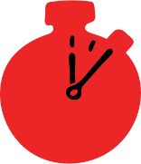
Group size

Whole group or small groups
Suggested timing

30 minutes
Method
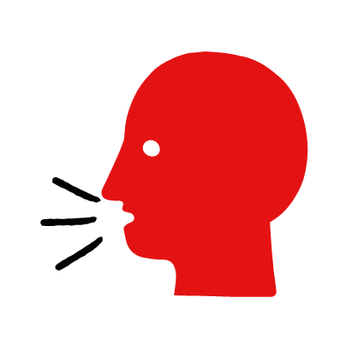

Discussion and film

Learning objectives
What you need
Seizure interactive activity (images and text) on the seizure first aid skill page

Learner skill guide ‘helping someone who is having a seizure’

- Learn how to recognise when someone is having a seizure.
- Learn the key action to help when someone is having a seizure.

Overview
Young people learn about seizures, what they are and what happens when someone is experiencing one. They then learn the steps to helping and the key action to take when someone is having a seizure, so that they are more able, willing and confident to help.

Preparation
Ensure you can access the First aid champions website and can move through the interactive activity on the seizure first aid skill page. Display or print off the Learner skill guide ‘helping someone who is having a seizure’.

Familiarise learners with the ground rules for the session or establish ground rules. For guidance on how to do that, see the Creating a safe, inclusive and supportive learning environment guidance.

How to run the activity

- Ask young people:
- What happens when someone has a seizure?
They may have collapsed. Their body may stiffen and be making jerky movements. They may also have froth around their mouth.
- What is epilepsy?
It is a medical condition that can cause a person to have seizures although not everyone who has a seizure has epilepsy.
- What feelings might there be when someone is having a seizure?
It can be very worrying when someone has a seizure. It is okay to feel worried, the most important thing to do is to recognise what is happening and to act calmly to help them.
- What can you do to help someone who is having a seizure?
Explain that in the next part of the activity the group are going to learn how to help someone who is having a seizure.
- Now go to the seizure first aid skill page. Display the interactive activity on the web page, this will appear as a series of slides you can work through with the group. Alternatively, you could set the group up with individual or shared screens to work through the activity.
- Display or direct the group to the confidence slider on the seizure first aid skill page, either setting this as an individual task or discussing as a group. How confident do learners feel to help someone who is having a seizure?
- On the seizure first aid skill page, watch Leo’s story. After showing the story, ask young people:
- What was happening in Leo’s story? He was playing video games with his friend Ethan, when he has a seizure.
- How did they recognise Ethan was having a seizure? He went stiff and started twitching and his eyes rolled backwards.
- How might they have felt? Think about the person having the seizure, the person who helped and anyone else nearby. They might say things like scared, confused but also things like glad they know what to do in future.
- What did they do to help? His brother Adam moved the table and put a blanket under Ethan’s head and called 999.
- What were they good at? What qualities did they show? They might say things like prepared, quick to act.
*The end of the film has the question “What would you do?” this is a rhetorical device only. You do not need to ask learners to share what they would do in this situation.

Questions learners might ask
Learners might have questions about this skill. Remember to provide an anonymous question box for questions they wish to ask privately. The key skills are the most important things they should remember, but you can find some extra information which might help you answer their questions here:
- How do I know if it’s necessary to call 999?
You should call 999 if:
- This is their first seizure or you are not sure if it is.
- The seizure lasts longer than 5 minutes
- They hurt themselves during the seizure
- You are unsure of the cause (for example, you don’t think they have epilepsy).

- Should I try and keep their tongue forward or put something in their mouth to stop them biting themselves?
No, do not go anywhere near the person’s mouth or put anything in it. You risk injuring both of you. Make the area safer for them and prevent injury whilst waiting for the seizure to finish.
- How do I know if they have epilepsy?
You may find some form of identification on the person such as a card, bracelet or necklace that gives information about their condition. If you can’t find anything and are unsure if they have previously had seizures, call 999.
- Display or hand out the Learner skill guide ‘helping someone who is having a seizure’. In small groups, or as a whole group look at the learner skill guide and discuss again some of the signs of a seizure and the key actions to help.
- Direct the group to the confidence slider on the seizure first aid skill page and complete it again.
- Check what learners have learned by doing the seizure quiz.

Stretch and challenge activities:
- Ask learners to explain or write down the key steps to help someone who is having a seizure. They could create a diagram to show what someone who is having a seizure might look like and the key actions to help.
- Compare their work to the photos of the webpage, did they miss anything? Could they add details of how someone can help support the person who is having a seizure emotionally too.

Summing up
- Remind the group that the most important thing to do is to make them safe and prevent injury.
- Now practise how to help someone who is having a seizure with the practise activity.

