15.Unresponsive and breathing
Group size

Whole group or small groups
Suggested timing

30 minutes
Method
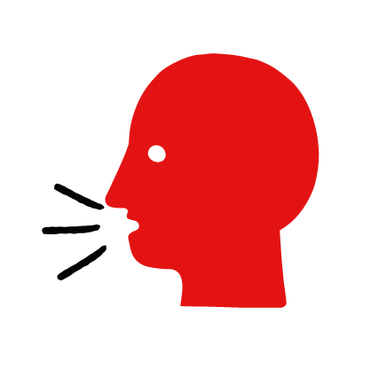

Discussion and film

Learning objectives
What you need
Unresponsive and breathing interactive activity (images and text) on the unresponsive and breathing first aid skill page

Learner skill guide ‘helping someone who is unresponsive and breathing’

- Learn first aid skills and about basic treatment for common injuries
- Feel confident to help someone who needs first aid
- Learn about helping others and kindness

Overview
Young people learn about someone who is unresponsive and breathing and what this means. They then learn the steps to helping and the key action to take when someone is unresponsive and breathing.

Preparation
Ensure you can access the First aid champions website and can move through the interactive activity on the unresponsive and breathing first aid skill page. Display or print off the Learner skill guide ‘helping someone who is unresponsive and breathing’.

How to run the activity

- Ask young people:
- What does unresponsive mean?
This is when someone is not moving and doesn’t respond when you call their name or shake their shoulders.
- How can you check if someone is breathing?
Tilt their head back and look at their chest or stomach to see if it is moving. Listen for breaths and feel for them on your cheek. If they are breathing, their chest or stomach will move. You should also hear or feel signs of breathing.
- Have you ever seen someone who is unresponsive and breathing? Possibly on TV or in a film?
Make sure young people know they don’t need to share if they find a story upsetting, but if they want to share, explain that they are going to learn how to help someone who is unresponsive and breathing.
- What feelings might there be when someone is unresponsive and breathing?
It can be very worrying when someone is unresponsive and breathing. It is okay to feel worried, the most important thing to do is to recognise what is happening and to calmly help them.
- What can you do to help someone who is unresponsive and breathing?
Explain that in the next part of the activity the group are going to learn how to help someone who is unresponsive and breathing.
- Now go to the unresponsive and breathing first aid skill page. Display the interactive activity on the web page, this will appear as a series of slides you can work through with the group. Alternatively, you could set the group up with individual or shared screens to work through the activity.
- Display or direct the group to the confidence slider on the unresponsive and breathing first aid skill page, either setting this as an individual task or discussing group. How confident do learners feel to help someone who is unresponsive and breathing?
- On the unresponsive and breathing first aid skill page, watch Raheem’s story. After showing the story, ask young people:
- What was happening in Raheem’s story?
- How did they recognise Mark wasn’t okay?
- How might Raheem and Sophie have felt?
- What is the action that Mark’s friends took to help? What else were they good at? What qualities did they show? What can you learn from this? How could you use it?
- Show the short-animated film which appears in the macro on the last slide of the unresponsive and breathing first aid skill page, this shows what happens in the body when someone is unresponsive and breathing. Direct the group to the confidence slider on the unresponsive and breathing first aid skill page and complete it again.
- Display or hand out the Learner skill guide ‘helping someone who is unresponsive and breathing’. In small groups, or as a whole group look at the learner skill guide and discuss again how they can identify if someone is unresponsive and breathing and what they would do to help.
- Individually, or in small groups choose one of the creative tasks below to complete the activity:
- Write or create a poster of how to identify if someone is unresponsive and breathing and the key action to take when someone is unresponsive and breathing.
- Create your own unresponsive and breathing story. They could map this out in pictures that they take as a group with text alongside, or just write text. They can create their story as a PowerPoint or as a short animation. Ensure that young people show the key action to take to help someone who is unresponsive and breathing and get this across as part of their story. They can then share with the rest of the group – time allowing.

Summing up
- Remind the group that the most important thing to do is to help.
- Now practise how to help someone who is unresponsive and breathing.

