10. Poisoning / harmful substances
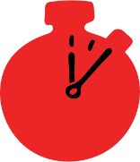
Group size

Whole group or small groups
Suggested timing

30 minutes
Method
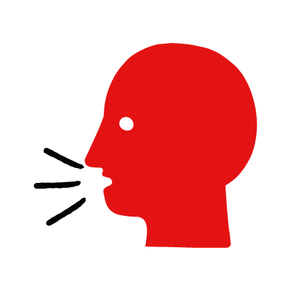

Discussion and film

Learning objectives
What you need
Harmful substances interactive activity (images and text) on the Poisoning / harmful substances first aid skill page

Learner skill guide ‘helping someone who has swallowed something harmful’

- Learn first aid skills and about basic treatment for common injuries
- Feel confident to help someone who needs first aid
- Learn about helping others and kindness

Overview
Young people learn about poisoning and what happens when someone swallows something harmful. They then learn the steps to helping and the key action to take when someone has swallowed something harmful.

Preparation
Ensure you can access the First aid champions website and can move through the interactive pages on the harmful substances first aid skill page. Display or print off the Learner skill guide ‘helping someone who has swallowed something harmful’.

How to run the activity

- Ask young people:
- What is a harmful substance?
Substances such as prescription or non-prescription drugs, household cleaning fluids and DIY products, and some plants can be harmful if you swallow them.
- What would make you think someone may have swallowed something harmful?
Someone may vomit and have stomach pains. There may be evidence of the harmful substance around their mouth or you may smell it. There may be empty containers nearby.
- Have you ever seen someone who has swallowed something harmful? Possibly on TV or in a film?
Make sure young people know they don’t need to share if they find a story upsetting, but if they want to share, explain that they are going to learn how to help someone who has swallowed something harmful.
  - What feelings might there be when someone has swallowed something harmful?
It can be very worrying when someone has swallowed harmful. It is okay to feel worried, the most important thing to do is to recognise what has happened and to act quickly and calmly to help them.
- What can you do to help someone who has swallowed something harmful?
Explain that in the next part of the activity the group are going to learn how to help someone who has swallowed something harmful.
- Now go to the harmful substances first aid skill page. Display the interactive activity on the web page, this will appear as a series of slides you can work through with the group. Alternatively, you could set the group up with individual or shared screens to work through the activity.
- Display or direct the group to the confidence slider on the harmful substances first aid skill page, either setting this as an individual task or discussing group. How confident do learners feel to help someone who has swallowed something harmful.
- On the harmful substances first aid skill page, move through Jade’s story, displayed as a series of images and text. You could ask learners to read out the slides. After showing the story, ask young people:
- What was happening in Jade’s story?
- Why was she worried about her friend?
- How might they have felt? Think about the person who had swallowed something harmful, the person who helped and anyone else nearby.
- What is the action that Jade took to help? What was she good at? What qualities did she show? What can you learn from this? How could you use it?
- Direct the group to the confidence slider on the harmful substances first aid skill page and complete it again.
- Display or hand out the Learner skill guide ‘helping someone who has swallowed something harmful’. In small groups, or as a whole group look at the learner skill guide and discuss again some of the signs of poisoning and what they would do to help.
- Individually, or in small groups, choose one of the creative tasks below to complete the activity:
- Write or create a poster of the key information you need to find out if you suspect someone has swallowed something harmful.
- Create your own poisoning story. They could map this out in pictures that they take as a group with text alongside, like in Jade’s story, or just write text. They can create their story as a PowerPoint or as a short animation, ensure that young people show the key action to take to help someone who has swallowed something harmful and get this across as part of their story. They can then share with the rest of the group – time allowing.

Summing up
- Remind the group that the most important thing to do is to help.
- Now practise how to help someone who has swallowed something harmful.

