3.Broken bone
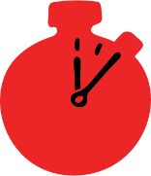
Group size

Whole group or small groups
Suggested timing

30 minutes
Method
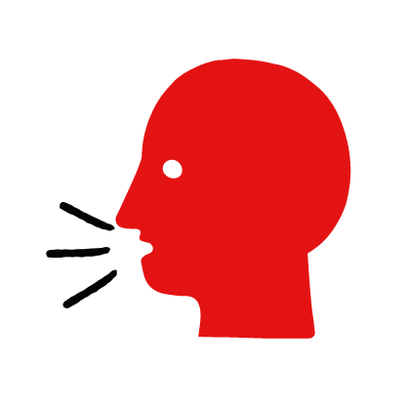

Discussion and film

Learning objectives
What you need
Broken bone interactive activity (images and text) on the broken bone first aid skill page

Learner skill guide ‘helping someone who has a broken bone’

- Learn first aid skills and about basic treatment for common injuries
- Feel confident to help someone who needs first aid
- Learn about helping others and kindness

Overview
Young people learn about broken bones, what they are and what happens when someone is experiencing one. They then learn the steps to helping and the key action to take when someone has a broken bone.

Preparation
Ensure you can access the First aid champions website and can move through the interactive activity on the broken bone first aid skill page. Display or print off the Learner skill guide ‘helping someone who has a broken bone’.

How to run the activity

- Ask young people:
- What could cause someone to break a bone?
Broken bones can be caused by a fall or a blow from an object.
- How could you tell if someone has a broken bone?
They may be in pain, have bruising and swelling or be lying in an unnatural position. It can be very difficult to tell if a bone is broken – usually an X-Ray is needed.
- Have you ever had a broken bone or know someone else who has? What happened?
Make sure young people know they don’t need to share if they find a story upsetting, but if they want to share, explain that they are going to learn how to help someone who is has a broken bone.
- What feelings might there be when someone has a broken bone?
It can be very worrying when someone has a broken bone. It is okay to feel worried, the most important thing to do is to recognise what is happening and to calmly help them.
- What can you do to help someone who you think has a broken bone?
Explain that in the next part of the activity the group are going to learn how to help someone who has a broken bone.
- Now go to the broken bone first aid skill page. Display the interactive activity on the web page, this will appear as a series of slides you can work through with the group. Alternatively, you could set the group up with individual or shared screens to work through the activity.
- Display or direct the group to the confidence slider on the broken bone first aid skill page, either setting this as an individual task or discussing as a group. How confident do learners feel to help someone who has a broken bone?
- On the broken bone first aid skill page, move through Rose’s story, displayed as a series of images and text. You could ask learners to read out the slides. After showing the story, ask young people:
- What was happening in Rose’s story?
- What caused Laura’s broken bone?
- How might they have felt? Think about the person with the broken bone, the person who helped and anyone else nearby.
- What are the actions that Laura’s friends took to help her? What else were they good at? What qualities did they show? What can you learn from this? How could you use it?
- Direct the group to the confidence slider on the broken bone first aid skill page and complete it again.
- Display or hand out the Learner skill guide ‘helping someone who has a broken bone’. In small groups, or as a whole group look at the learner skill guide and discuss again some of the signs of a broken bone and what they would do to help.
- Individually, or in small groups choose one of the creative tasks below to complete the activity:
- Write or create a poster of how to recognise a broken bone and the key action to take is when you think someone has a broken bone.
- Create your own broken bone story. They could map this out in pictures that they take as a group with text alongside, like in Rose’s story, or just write text. They can create their story as a PowerPoint or as a short animation, ensure that young people show the key action to take to help someone who has a broken bone and get this across as part of their story. They can then share with the rest of the group – time allowing.

Summing up
- Remind the group that the most important thing to do is to help.
- Now practise how to help someone who has a broken bone.

