6.Head injury
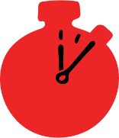
Group size

Whole group or small groups
Suggested timing

30 minutes
Method
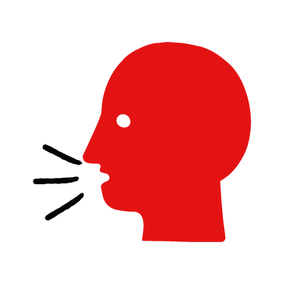

Discussion and film

Learning objectives
What you need
Head injury interactive activity (images and text) on the head injury first aid skill page

Learner skill guide ‘helping someone who is having a head injury’

- Learn how to recognize when someone has had a head injury.
- Learn the key action to help when someone has had a head injury.

Overview
Young people learn about head injuries, what they are and what happens when someone has one. They then learn the steps to helping and the key action to take when someone has a head injury so that they are more able, willing and confident to help.

Preparation
Ensure you can access the First aid champions website and can move through the interactive activity on the head injury first aid skill page. Display or print off the learner skill guide ‘helping someone who has a head injury’.

Familiarise learners with the ground rules for the session or establish ground rules. For guidance on how to do that, see the Creating a safe, inclusive and supportive learning environment guidance.

How to run the activity

- Ask young people:
- What could cause someone to have a head injury? Head injuries are caused when someone has an accident where they hit their head.
- What happens when someone has a head injury? They may be in pain, have a headache and have a lump on their head. If someone has a serious head injury they may also vomit, feel sick, confused or drowsy – this is a more serious condition and needs medical attention.
- What can you do to help someone who has a head injury? Explain that in the next part of the activity the group are going to learn how to help someone who has a head injury.
- Now go to the head injury first aid skill page. Display the interactive activity on the web page, this will appear as a series of slides you can work through with the group. Alternatively, you could set the group up with individual or shared screens to work through the activity.
- Display or direct the group to the confidence slider on the head injury first aid skill page, either setting this as an individual task or discussing as a group. How confident do learners feel to help someone who has a head injury?
- On the head injury first aid skill page, move through Nick’s story, displayed as a series of images and text. You could ask learners to read out the slides. After showing the story, ask young people:
- What was happening in Nick’s story? Nick and Simon were playing badminton and Simon fell and hit his head.
- What caused Simon’s head injury? He dived to reach a shot, and fell, hitting his head on the gym bench.
- How might they have felt? Think about the person with the head injury, the person who helped and anyone else nearby. They might say things like, worried, scared, in pain, but also things like confident, ready to help, supported.
- What is the action that Nick took to help? Went over to see if he was okay, checked to see whether he was bleeding or if there was a lump. Grabbed an icepack from the gym reception and wrapped it in a t-shirt. Sat with him, called his sister to pick him up and waited with him until she arrived.
- What else were they good at? What qualities did they show? They might say things like, Nick was kind, he was calm under pressure. Simon let Nick help him and didn’t just dismiss it, he took it seriously.
- Show the short-animated film which appears in the activity on the head injury first aid skill page, this shows what happens in the body when someone has a head injury.

Questions learners might ask
Learners might have questions about this skill. It’s important to give them space to ask questions. Remember to provide an anonymous question box for questions they wish to ask privately. The key skills are the most important things they should remember, but you can find some extra information which might help you answer their questions here:
- How long do I rest with something cold on the injury?
You should hold something cold to the injury for up to 20 minutes and get them to rest until they feel better. After that you should keep an eye on them to look out for signs that the head injury might be serious, like if they become sleepy, if they vomit, or if they start to act strangely.
Tell an adult what happened and to look after them. If they got the head injury playing sports, they need to be seen by a medical professional before they can go back to playing sports.
- What should I do if the head injury is bleeding a lot?
Press hard on the bleed, like you would in the ‘bleeding’ skill and call 999.
- When should I call 999 for a head injury?
Call 999 if: They become less responsive or unresponsive; They have numbness or weakness in any part of their body; They have clear fluid or blood coming from their ears or nose; They suffer a seizure; They have been in a serious accident or had a severe blow to the head
You should also seek medical advice if you are unsure how bad the injury is but think it could be serious, or if the person is over 65, takes medicine to thin their blood, has been drinking or taking drugs, has had a brain injury before or has no one to look after them.

- Display or hand out the Learner skill guide ‘helping someone who has a head injury’. In small groups, or as a whole group look at the learner skill guide and discuss again some of the signs of a head injury and the key actions to help.
- Direct the group to the confidence slider on the head injury first aid skill page and complete it again.
- Check what learners have learned by doing the head injury quiz.

Stretch and challenge activities:
- Ask learners to explain or write down the key steps to help someone who has a head injury. They could create a diagram to show what someone who has a head injury might look like and the key actions someone helping should do.
- Compare their work to the photos of the webpage, did they miss anything? Could they add details of how someone can help support the person who has a head injury emotionally too.

Summing up
- Remind the group that the most important thing to do is to put something cold on the injury.
- Now practise how to help someone who has a head injury with the practise activity.

