16.Unresponsive and not breathing
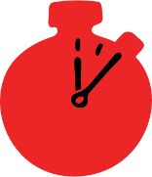
Group size

Whole group or small groups
Suggested timing

30 minutes
Method
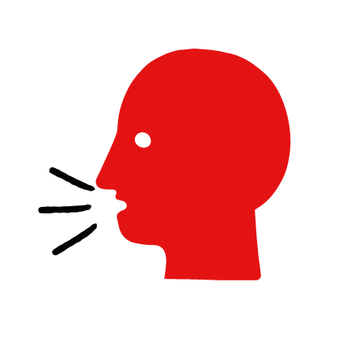

Discussion and film

Learning objectives
What you need
Unresponsive and not breathing interactive activity (images and text) on the unresponsive and not breathing first aid skill page

Learner skill guide ‘helping someone who is unresponsive and not breathing’

- Learn how to recognize when someone is unresponsive and not breathing.
- Learn the key action to help when someone is unresponsive and not breathing.

Overview
Young people learn about someone who is unresponsive and not breathing and what this means. They then learn the steps to helping and the key action to take when someone is unresponsive and not breathing, so that they are more able, willing and confident to help.

Preparation
Ensure you can access the First aid champions website and can move through the interactive pages on the unresponsive and not breathing first aid skill page. Display or print off the Learner skill guide ‘helping someone who is unresponsive and not breathing’.

Familiarise learners with the ground rules for the session or establish ground rules. For guidance on how to do that, see the Creating a safe, inclusive and supportive learning environment guidance.

How to run the activity

- Ask young people:
- What does unresponsive mean? This is when someone is not moving and doesn’t respond when you call their name or tap their shoulders. If it is an adult who is unresponsive, you may need to shake their shoulders or tap harder.
- How can you check if someone is breathing? Tilt their head back and look at their chest or stomach to see if it is moving. Listen for breaths and feel for them on your cheek. If they are not breathing, their chest or stomach will not move. You won’t hear or feel signs of breathing.
- What feelings might there be when someone is unresponsive and not breathing? It can be very worrying when someone is unresponsive and not breathing. It is okay to feel worried, the most important thing to do is to act quickly to help them and try to stay calm.
- What can you do to help someone who is unresponsive and not breathing? Explain that in the next part of the activity the group are going to learn how to help someone who is unresponsive and not breathing.

Now go to the unresponsive and not breathing first aid skill page. Display the interactive activity on the web page, this will appear as a series of slides you can work through with the group. Alternatively, you could set the group up with individual or shared screens to work through the activity.
- Display or direct the group to the confidence slider on the unresponsive and not breathing first aid skill page, either setting this as an individual task or discussing group. How confident do learners feel to help someone who is unresponsive and not breathing?
- On the unresponsive and not breathing first aid skill page, watch Kelly’s story. After showing the story, ask young people:
- What was happening in Kelly’s story? She went to visit her nan and saw her unresponsive in the garden.
- What did Kelly do when she found her nan? She started shouting for help.
- How might Kelly have felt? Think about the Tom next door, how might he have felt? They might say things like scared, panicked, but also things like, ready to help, confident.
- What is the action that Tom took to help? He told Kelly to call 999 as he gave her nan chest compressons.
- What was he good at? What qualities did he show? They might say things like calm under pressure, helpful.
- Show the short-animated film which appears in the activity on the last slide of the unresponsive and not breathing first aid skill page. This shows what happens in the body when someone is unresponsive and not breathing.

Questions learners might ask

Learners might have questions about this skill. Remember to provide an anonymous question box for questions they wish to ask privately. The key skills are the most important things they should remember, but you can find some extra information which might help you answer their questions here:
- How fast should I do chest compressions?
You are aiming for a speed of two chest compressions per second.
- How hard should I press when doing the chest compressions?
You are aiming to push down to around a third of the depth of their chest.
- Do I have to give “mouth to mouth”?
If you able and comfortable you can do rescue breaths as well. After 30 chest compressions, give five rescue breaths: tilt their head back, seal your mouth over their mouth and pinch their nose. Blow five times into the person’s mouth. Then continue this cycle of breaths and compressions until help arrives.
- What if the person is a very young child?
Then do the same action with only one hand pushing on their chest and make sure you do the five rescue breaths after 30 compressions. Repeat this cycle until help arrives.
Babies have to be treated differently. Look at the British Red Cross Baby and Child app for details about how to treat babies.

- Display or hand out the Learner skill guide ‘helping someone who is unresponsive and not breathing’. In small groups, or as a whole group look at the learner skill guide and discuss again how to identify if someone is unresponsive and not breathing and the key actions to help.
- Direct the group to the confidence slider on the unresponsive and not breathing first aid skill page and complete it again.
- Check what learners have learned by doing the unresponsive and not breathing first aid skill page.

Stretch and challenge activities:
- Ask learners to explain or write down the key steps to help someone who is unresponsive and not breathing. They could create a diagram to show what someone who is unresponsive and not breathing might look like and the key actions someone helping should do.
- Compare their work to the photos of the webpage, did they miss anything? Could they add details of how someone can help support the person who is unresponsive and not breathing emotionally too.

Summing up
- Remind the group that the most important thing to do is to call 999 and give chest compressions.
- Now practise how to help someone who is unresponsive and not breathing with the practise activity.

