Creating a safe, inclusive and supportive learning environment
This activity and guidance can be used alongside any of the British Red Cross teaching resources; they are designed to support teachers to create safe, inclusive and supportive learning environments in which to explore a wide variety of topics, values and concepts.

This document contains:
- Introduction
- Guidance: Managing sensitive or challenging content
- Guidance: Answering questions safely and appropriately: creating opportunities for open discussion
- Guidance: Using distancing techniques as part of some learning activities
- Activity: Feedback technique: two stars and a wish
- Activity: Creating a group agreement

Introduction
Creating a safe, inclusive and supportive learning environment is essential to enable children and young people to explore topics, their own experiences, and the experiences of others safely and sensitively in order that they can learn in a positive, supportive and empowering environment.

Whilst exploring the teaching resources with children and young people, maintain an awareness that some pupils may have first-hand experience of some of the situations being explored as part of the resources. This document provides you with a range of guidance, support and two activity ideas; to ensure that pupils feel safe, supported and encouraged to deepen and further their learning, either by choosing to participate or being able to pass if they don’t feel able to contribute.

Each school will have its own safeguarding, child protection, confidentiality and other relevant policies, as well as knowledge of pupils with particular needs or backgrounds that may need extra support, including the protocols that work best for them. This document can be used in conjunction with your school policies and context, to ensure children and young people feel safe, supported and included in their learning.

Guidance

Managing sensitive or challenging content
Some pupils in your class may have first-hand experience of or have family or friends that have experienced some of the content within the resource, and may find some sessions potentially challenging and/or upsetting. For example, when exploring first aid resources a pupil might have experience of having an asthma attack or know someone who has had a heart attack; it may bring back memories or bring up questions for other members of the class.
Before delivering a session it is essential to consider who is in your group and the experiences and backgrounds they bring. Ensure pupils are aware of what you will be covering so they can opt out of the session if they wish or have a designated person to speak to if needed. You can use the group agreement activity later in this document at the start of sessions to ensure pupils are clear on what they can share and who they can go to for support if required.

Ensure that pupils are aware that they can access support or further guidance after sessions, identify who this is in your school; you could also suggest that they talk to trusted adults in or out of school, or identify appropriate organisations and/or websites relating to what they have learned. For example if pupils want to learn more about a topic they have been exploring such as first aid, they could be signposted to websites such as the British Red Cross teaching resources to explore.

Guidance

Answering questions safely and appropriately: creating opportunities for open discussion
A safe, inclusive and supportive learning environment helps pupils explore values and actions, express themselves, listen to others, develop empathy and share their ideas and feelings.
Fostering an environment of open discussion can support learning around a variety of topics.

Sometimes students may have questions that are complex or challenging to unpack and answer.
This guidance suggests some options for how to approach answering questions safely and appropriately.

Options for managing a complex or challenging question:
- Praise pupils for asking questions.
- Show that you value the question; ask the pupil for any clarifying points if needed.
- It is fine for you not to know the answer to a question and to let the student(s) know this – this can create a supportive feeling of “learning together”.
- Explain that this is a very interesting question that deserves a thorough answer; say you will come back to the pupil/class once you have had time to look into it.
- Consider whether you need to explore a topic in more depth to answer the question(s). If you are exploring a British Red Cross topic you can look at the teacher briefings on the website, some resources also contain overview documents or FAQs to support you with background information.
- For other questions you might consider consulting a colleague or senior colleagues, looking at any relevant school policies including safeguarding if needed.
- Before answering, you could ask the pupil what they think the answer is and build on their existing understanding.
- Consider the appropriate response to a question; for example, a short, simple answer for a whole class; or taking more time to answer questions after a session if the answer is more specific or in-depth than you are able to go into in the lesson. For the latter, you could value the question but explain it goes beyond what you’ll be exploring in class today and that you can pick this up with them/the class later or at another time (make a note of this).
- You could consider creating an “anonymous questions” box, available for use before, during and after the session if this is appropriate.
You can use the group agreement activity in this document to support you with enabling open discussion and creating a safe environment to answer questions safely and appropriately.

Guidance

Using distancing techniques as part of some learning activities
Some of the teaching resources use methods such as role play and other drama-based activities; as well as images, case studies, comic strips and films, asking pupils to put themselves in the position of someone else or to empathise with how someone might feel in a particular situation.

Distancing techniques help to keep pupils emotionally safe, giving them the chance to consciously step back, debrief and return to “normal” after an activity.
When using the resources, support pupils to distance themselves from the learning before and after taking part. For example, before starting the activity, discuss the idea of “distancing techniques” and constructive, structured and supportive feedback with your group – this is to ensure that young people feel safe whilst taking part in active learning.

Depending on the activity you might discuss:
- Role-playing the character – not yourself or someone/people you know. It is important to maintain people’s confidentially by not naming someone you know, even if the role is similar.
- That if the activity involves role-play or creating a scenario, ensure it is a situation that no one in your group might find upsetting, and that the scene is made up rather than enacting something that has happened.
- That when watching others’ role plays or presentations and feeding back, ensure there is a structure for the feedback (see feedback technique activity below). If you use feedback, ensure everyone in the group knows the criteria.
- How anyone can opt out of a role or activity if they feel uncomfortable; instead, they can write a story, or create a cartoon script or drawing of the scenario to demonstrate their learning
- The need to take time to “come out of the role” or to step back from empathising with a person or situation with a chance to debrief before finishing the session
- Why it is helpful to use distancing techniques
- Who they can speak to if they need to follow up after an activity.

Activity

Feedback technique: two stars and a wish
If you choose for the group to feedback on each other’s role plays or presentations, they could use the “two stars and a wish” structure:
- Each group is allocated another group that they will give feedback to.
- They watch the presentation or role-play, taking notes if needed and then formulate their feedback using sensitive and supportive language, structuring comments as two positives (two stars) that they thought went well or helped others learn or showed skill; and one area for development (a wish) that they thought could have come across better or could be developed.

Activity

Creating a group agreement Suggested timing: 5–10 minutes
Developing a group agreement or ground rules with your class creates the basis of a safe learning environment supporting more open discussion; in particular, resources that have a focus on skills, values and attitudes, where pupils will be exploring potentially new ideas and developing their own thinking and opinions, can benefit from a group agreement. Group agreements can also help with managing any unexpected disclosures or comments.

Group agreements are most effective when they have been developed with pupils; you can help to strengthen the agreement by modelling the behaviours in your communication and approach.

This activity suggests how to set a group agreement with your class, helping pupils to consider: how they would like to work together, what rules and boundaries they would like in place in the sessions, and how they can help and support one another to engage in the topic(s) and their own learning.
Revisiting the group agreement during class or at the start of sessions can help to maintain a safe, inclusive and supportive learning environment; and can be an opportunity to renegotiate or emphasise the agreement.
Ask the class to think about a time when they had rules or agreements for a group. Suggested discussion questions:
- What kinds of groups might you have had rules or agreements for?
- Have these rules or agreements worked? What were they useful for?
- How effective were the rules or agreements in keeping people safe? e.g. physically safe, emotionally safe
- How might rules or agreements support our learning during the session today?

Show the prompt ideas from the Creating a safe, inclusive and supportive learning environment group agreement slide.
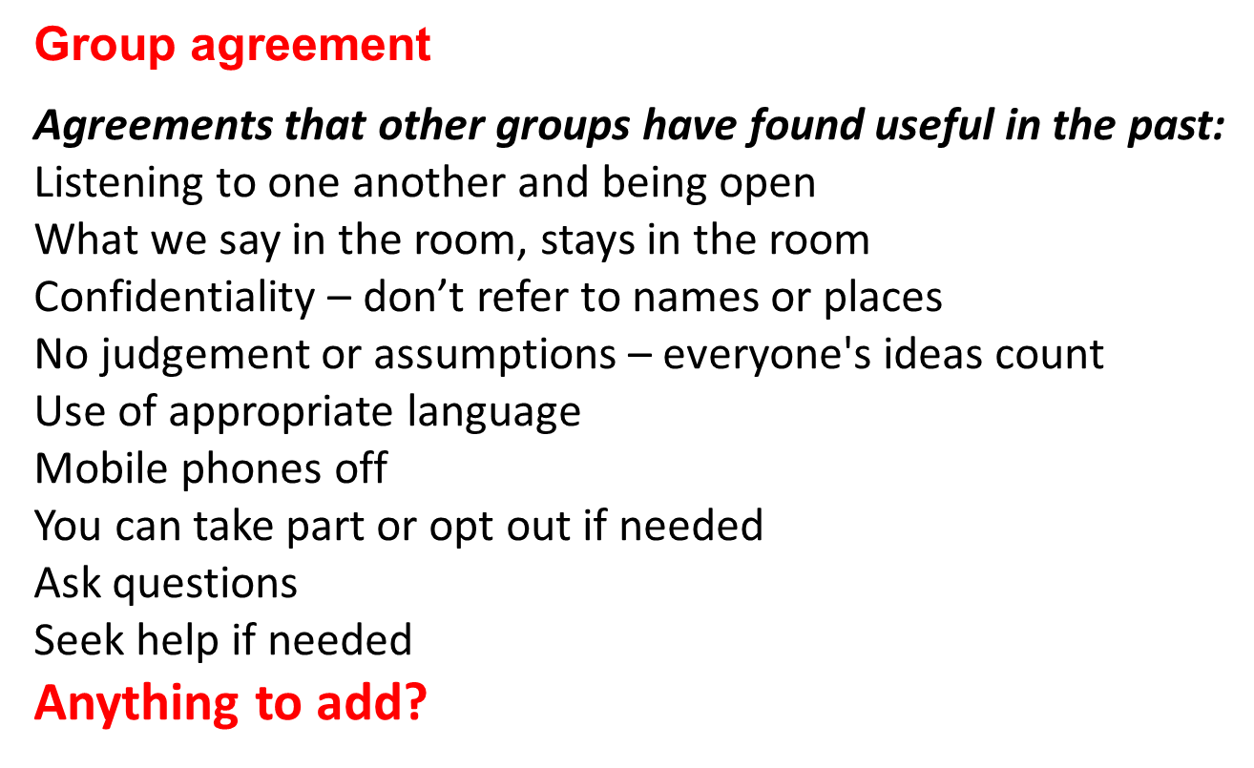

Ask the class to form pairs and discuss what group rules they would like for the whole group.

Ask for ideas from the group, capturing them on a flipchart so that they can be used again. Remind the class that this is a group agreement: anyone in the group can refer to the group agreement at any time to help keep everyone on track.

If you have more than one session you can return to the group agreement at the start of each session, reminding the group of their ideas and asking them if there is anything they would like to add, and if anything has changed, or needs addressing or a different approach.

Some of the ideas for this document were taken from the PSHE education character curriculum toolkit. If you would like to explore this in more detail please follow this link: https://www.pshe-association.org.uk/curriculum-and-resources/resources/pshe-education-character-curriculum-planning in particular look at section four. Please note that you need to be a member of the PSHE Association to access this content.

