12.Severe allergic reaction
Group size

Whole group or small groups
Suggested timing

30 minutes
Method
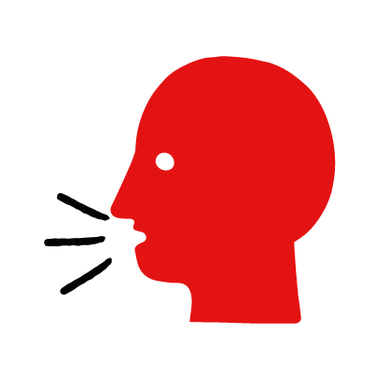

Discussion and film

Learning objectives
What you need
Severe allergic reaction interactive activity (images and text) on the severe allergic reaction first aid skill page

Learner skill guide ‘helping someone who is having a severe allergic reaction’

- Learn first aid skills and about basic treatment for common injuries
- Feel confident to help someone who needs first aid
- Learn about helping others and kindness

Overview
Young people learn about severe allergic reactions, what they are and what happens when someone is experiencing one. They then learn the steps to helping and the key action to take when someone is having a severe allergic reaction.

Preparation
Ensure you can access the First aid champions website and can move through the interactive activity on the severe allergic reaction first aid skill page. Display or print off the Learner skill guide ‘helping someone who is having a severe allergic reaction’.

How to run the activity

- Ask young people:
- What can cause a severe allergic reaction?
Someone could have a severe allergic reaction if they come into contact with something that they have a severe allergy to. It could be food, such as nuts or shellfish or other triggers such as insect stings or latex.
- What happens when someone has a severe allergic reaction?
They may develop a rash, itchiness or swelling on their hands, feet or face. Their breathing may slow down.
- Have you ever seen someone having a severe allergic reaction? Do you know anyone with a severe allergy?
Make sure young people know they don’t need to share if they find a story upsetting, but if they want to share, explain that they are going to learn how to help someone who is having a severe allergic reaction.
- What is an auto-injector? How do you use one?
Auto-injectors contain medicine that can help someone who is having a severe allergic reaction by making it easier for them to breathe. They have instructions on the side to tell you how to use them if the person is unable to use it themselves.
- What feelings might there be when someone is having a severe allergic reaction?
It can be very worrying when someone is having a severe allergic reaction. It is okay to feel worried, the most important thing to do is to recognise what is happening and to act quickly and calmly to help them.
- What can you do to help someone who is having a severe allergic reaction?
Explain that in the next part of the activity the group are going to learn how to help someone who is having a severe allergic reaction.
- Now go to the severe allergic reaction first aid skill page. Display the interactive activity on the web page, this will appear as a series of slides you can work through with the group. Alternatively, you could set the group up with individual or shared screens to work through the activity.
- Display or direct the group to the confidence slider on the severe allergic reaction first aid skill page, either setting this as an individual task or discussing as a group. How confident do learners feel to help someone who is having a severe allergic reaction?
- On the severe allergic reaction first aid skill page, move through Finn’s story, displayed as a series of images and text. You could ask learners to read out the slides. After showing the story, ask young people:
- What was happening in Finn’s story?
- How did Joanna recognise Finn was having a severe allergic reaction?
- What did Joanna do to help?
- How might they have felt? Think about the person having the severe allergic reaction, the person who helped and anyone else nearby.
- What is the action that Joanna took to help? What else were they good at? What qualities did they show? What can you learn from this? How could you use it?
- Direct the group to the confidence slider on the severe allergic reaction first aid skill page and complete it again.
- Display or hand out the Learner skill guide ‘helping someone who is having a severe allergic reaction’. In small groups, or as a whole group look at the learner skill guide and discuss again some of the signs of a severe allergic reaction and what they would do to help.
- Individually, or in small groups choose one of the creative tasks below to complete the activity:
- Write or create a poster of how to recognise a severe allergic reaction and the key action to take when someone is having a severe allergic reaction.
- Create your own severe allergic reaction story. They could map this out in pictures that they take as a group with text alongside, like in Finn’s story, or just write text. They can create their story as a PowerPoint or as a short animation. Ensure that young people show the key action to take to help someone who is having a severe allergic reaction and get this across as part of their story. They can then share with the rest of the group – time allowing.

Summing up
- Remind the group that the most important thing to do is to help.
- Now practise how to help someone who is having a severe allergic reaction.

